

Benefits & Claims / Non-disability team

April 2024 | Burial benefits form Product/Guide

Version 001

Revision History

| Date | Version | Description | Author |
| --- | --- | --- | --- |
| Unknown | 0 | The initial debut of the product did not have one |  |
| 05/??/2024 | 001 | Creation of product guide | Non-disability team: Fiorella Geedi |

Table of Contents (**CUSTOMIZE AS NEEDED**)

**1. Product Overview** **4**

**2. User Access** **4**

**3. Navigation** **4**

Main menu 4

How to apply: Not signed in 4

How to apply: In-progress and signed in 4

About form 530EZ 4

**4. Functionality** **5**

Introduction page 5

Step 1: Your information 5

Step 2: Deceased Veteran information 5

Step 3: Military History 5

Step 4: Benefit selection 6

Step 5: Upload documents 6

Step 6: Review 6

Confirmation 6

**5. Major Issues and Error Messages** **6**

Required response 6

Privacy policy 6

Missing information 6

Submission failure 6

## 1. Product Overview

The Veterans Burial Allowance online form (equivalent to VA Form 21P-530EZ), is a form the Veteran’s surviving spouse, partner, child, parent, executor, or administrator of the Veteran’s estate can apply to receive burial, plot, and transportation allowances.

## 2. User Access

Who can access this form?

* **Authenticated users:** Veteran’s surviving spouse, partner, child, parent, executor, or administrator of the Veteran’s estate **with a VA.gov account**.
* **Unauthenticated users:** Veteran’s surviving spouse, partner, child, parent, executor, or administrator of the Veteran’s estate **without a VA.gov account**.

## 3. Navigation

How can claimants access this form?

Claimants can go to VA.gov to access this form from the following pages:

* How to apply page: <https://www.va.gov/burials-memorials/veterans-burial-allowance/>
* About form 530EZ: <https://www.va.gov/find-forms/about-form-21p-530ez/>
* Online form: <https://www.va.gov/burials-and-memorials/application/530/introduction>
* Search results
* PDF: There might be direct links on PDFs at VA.gov

##### Main menu

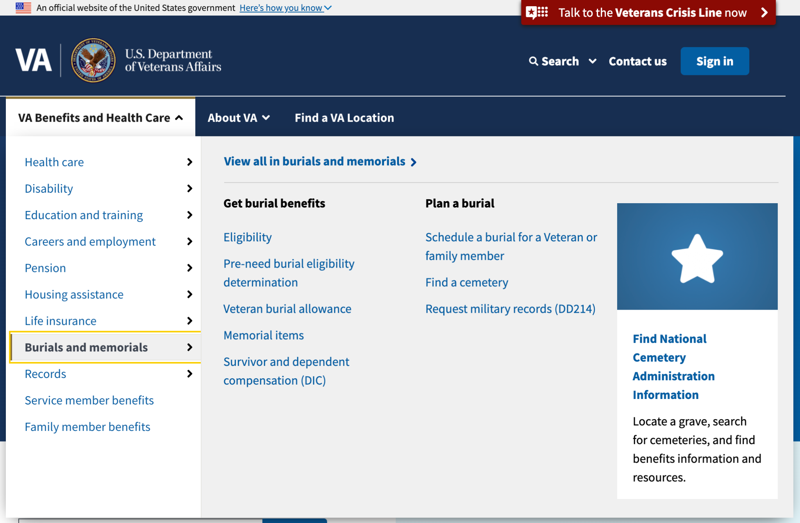

##### How to apply: Link to the application form

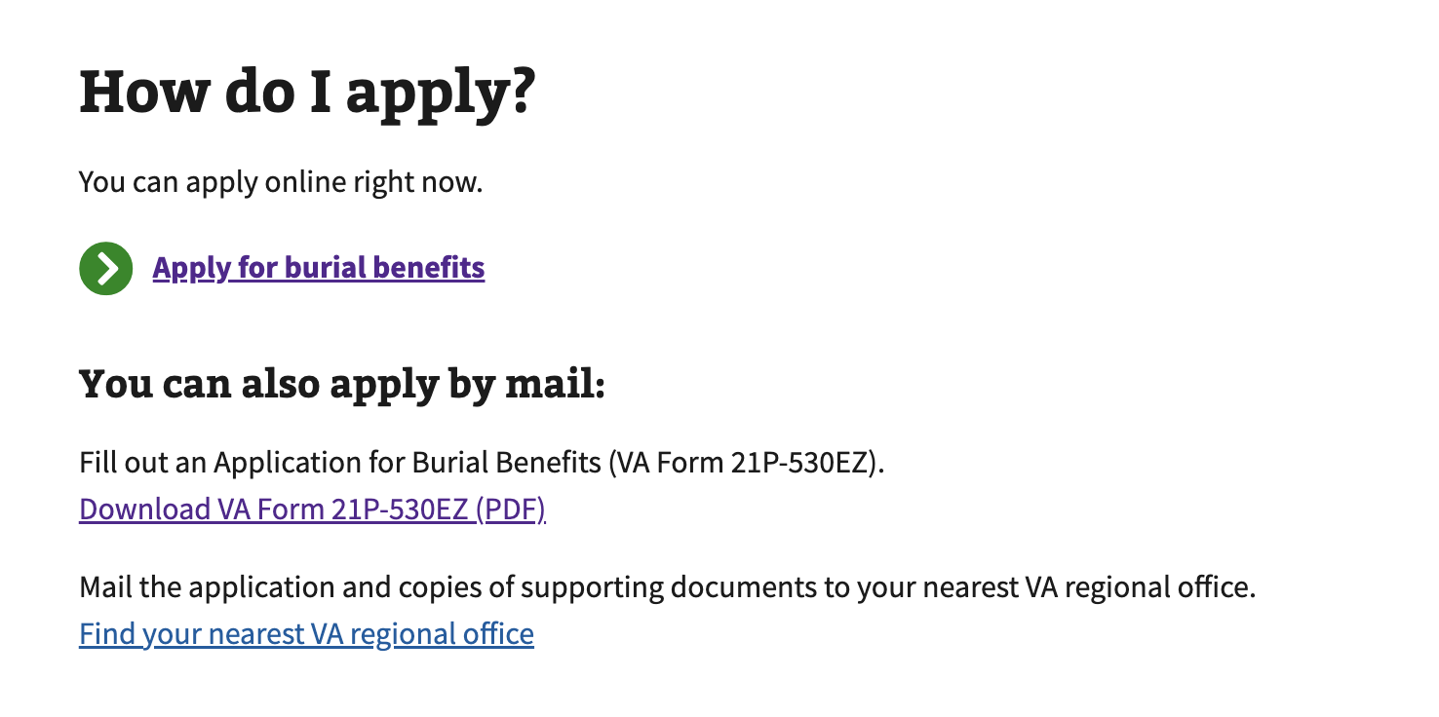

##### About form 530EZ

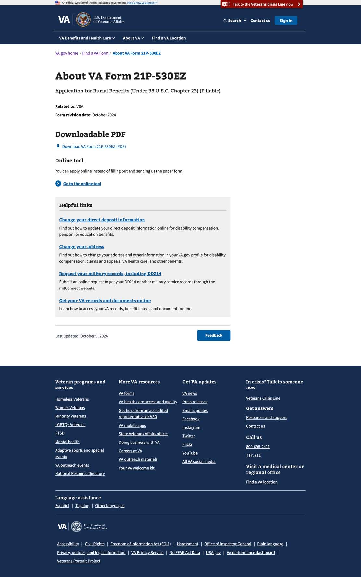

## 4. Functionality

Direct URL of the form: <https://www.va.gov/burials-and-memorials/application/530/introduction>

### Introduction page

This page explains what is expected from the claimant and it lists the following:

* Check eligibility: Remings the claimant to review the eligibility page before they apply
* Gather your information: It lists all the information the claimant might need about the deceased Veteran
* Apply: Explains how long it should take
* After you apply: This section explains what happens after the claimant submits the form.

#### Not signed-in

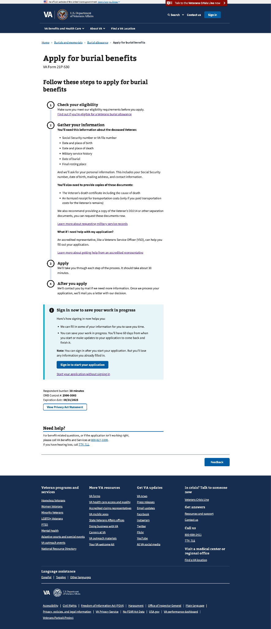

#### Signed-in

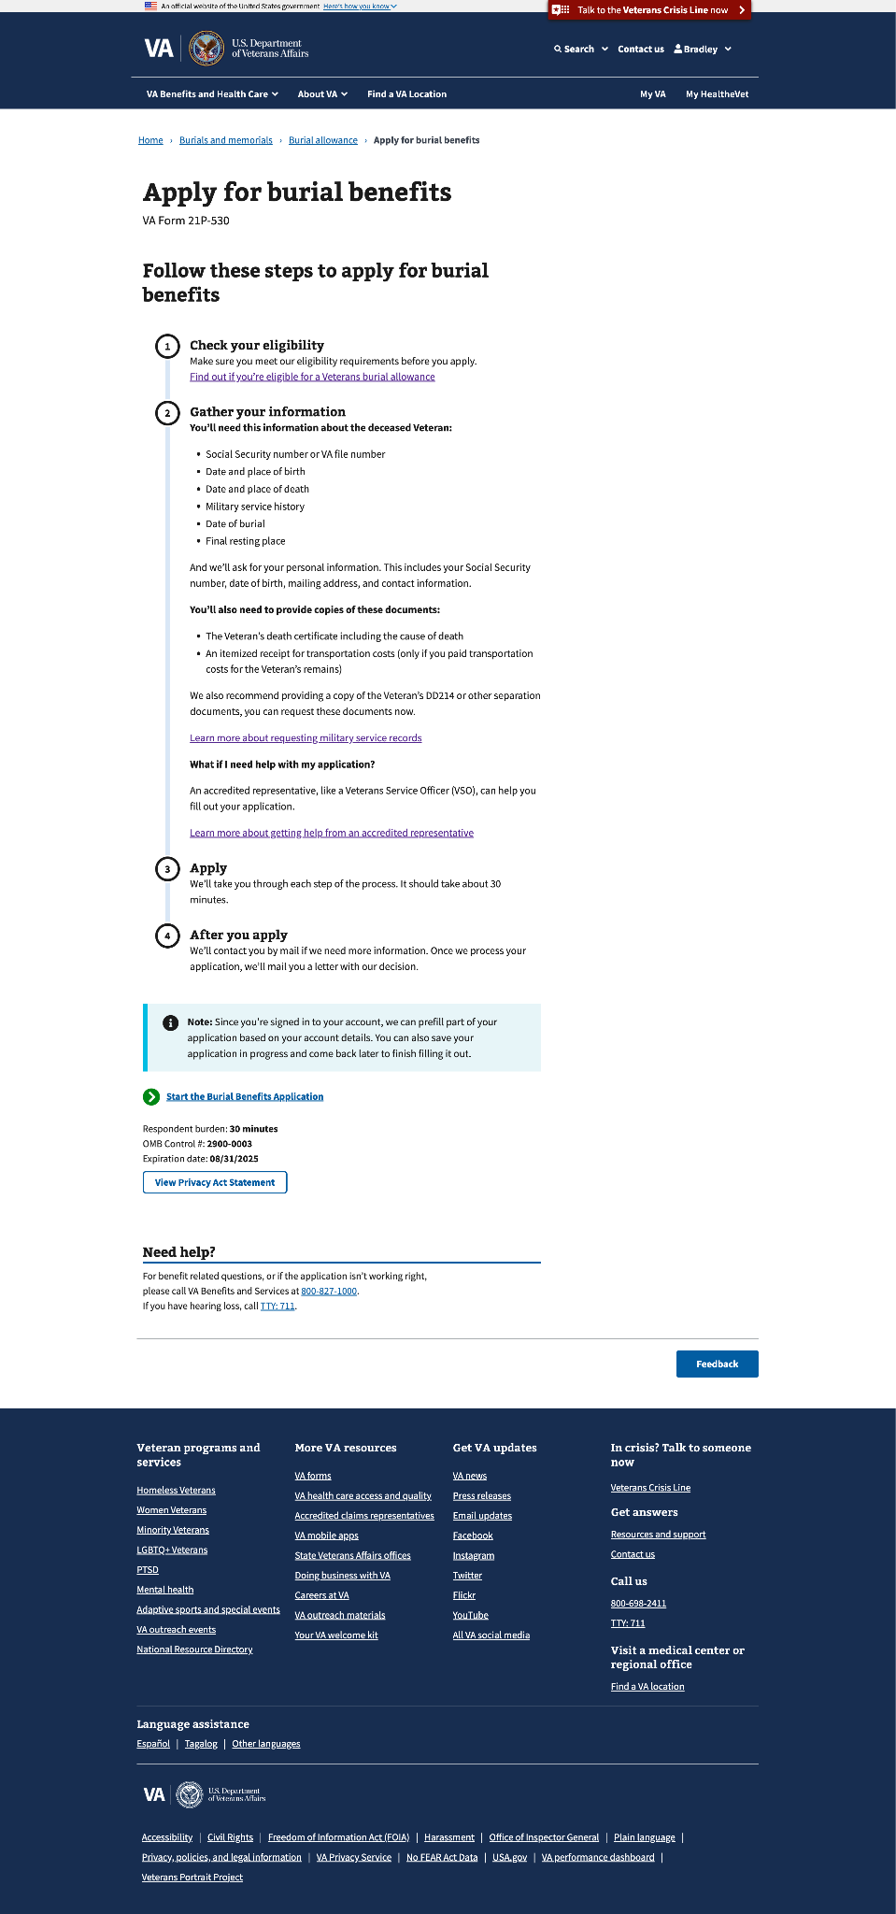

#### In-process

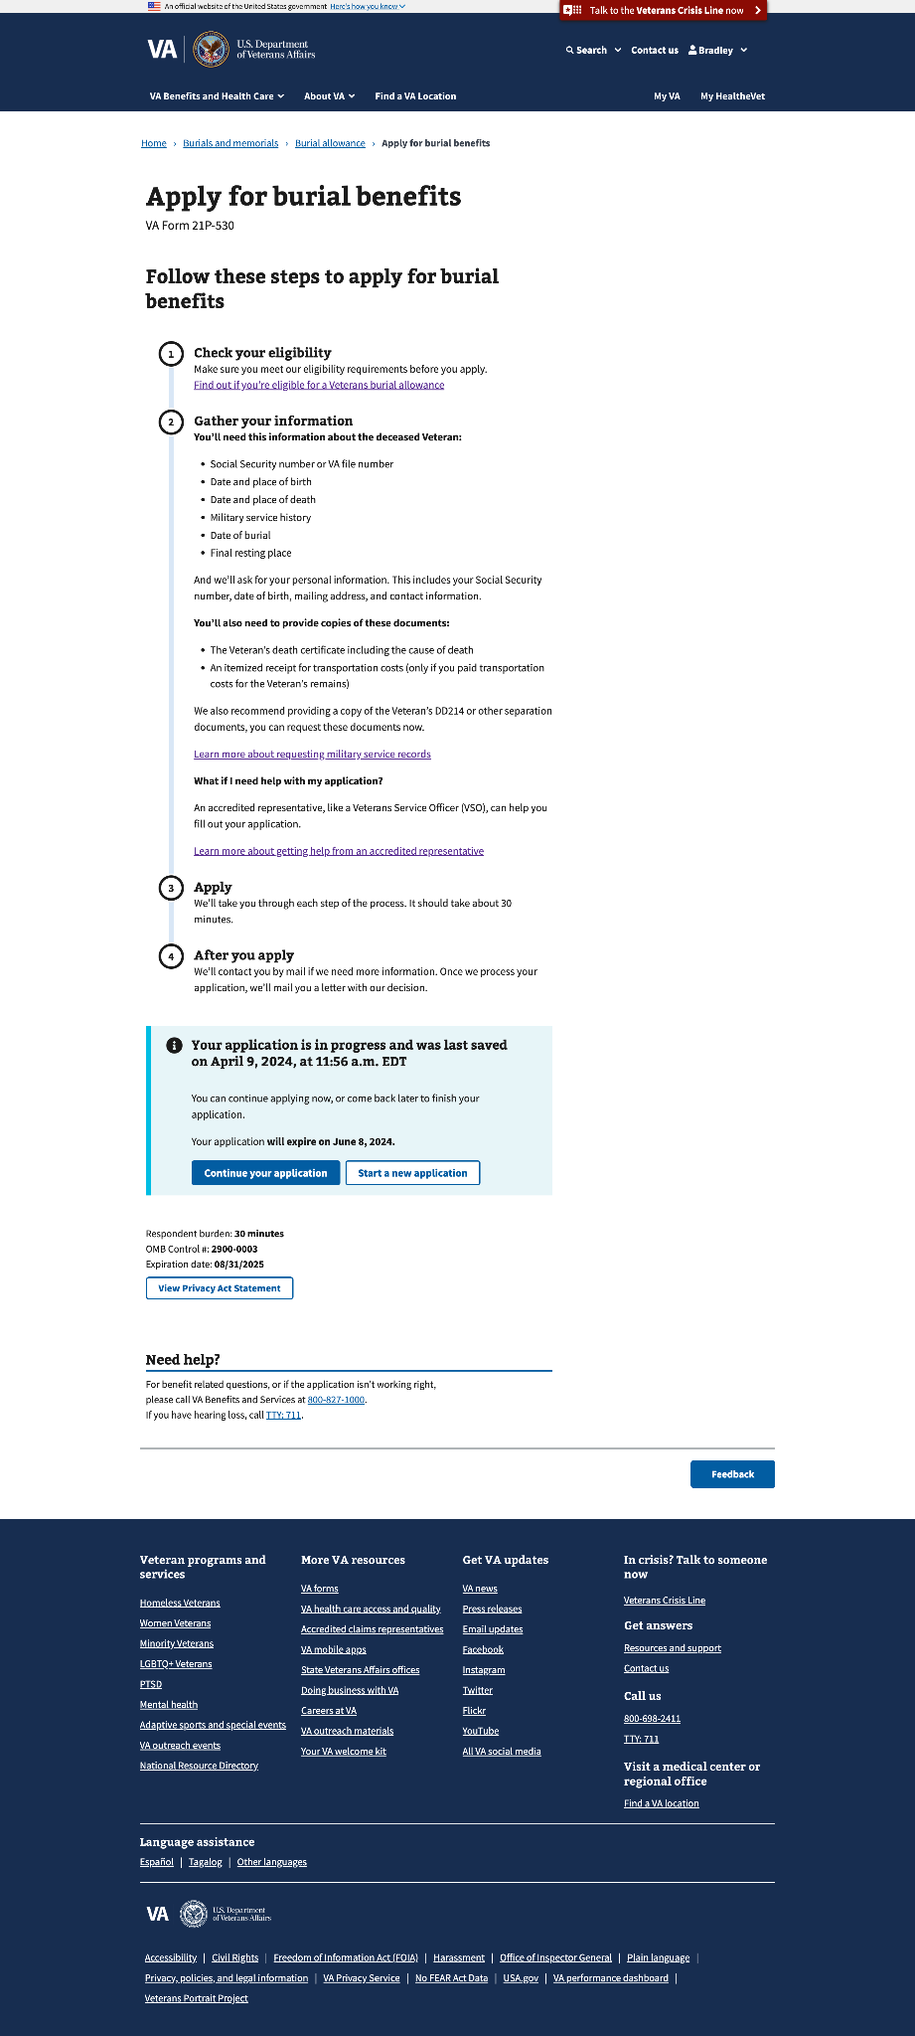

### Step 1: Your information

This step has 4 sup-pages that ask about the claimant’s relationship to the Veteran, personal information, mailing address, and contact information

#### 1.0 Relationship to Veteran

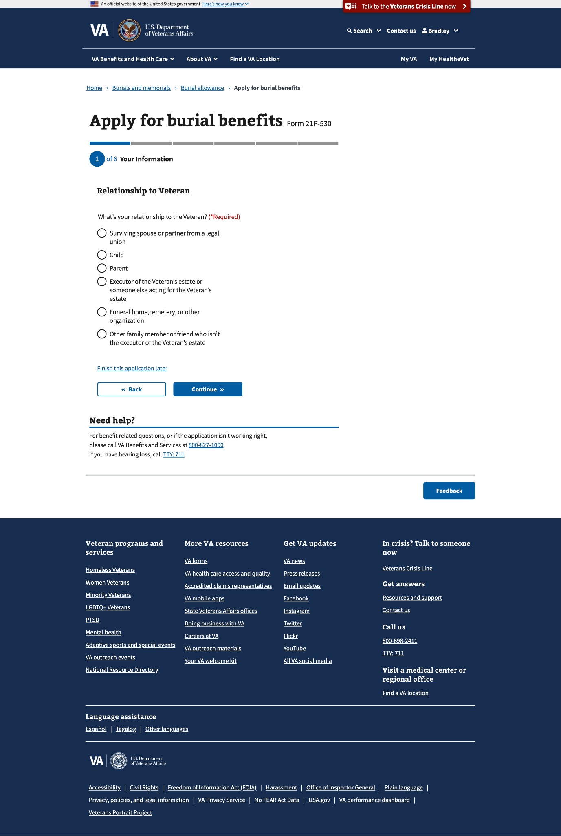

#### 1.1 Personal Information

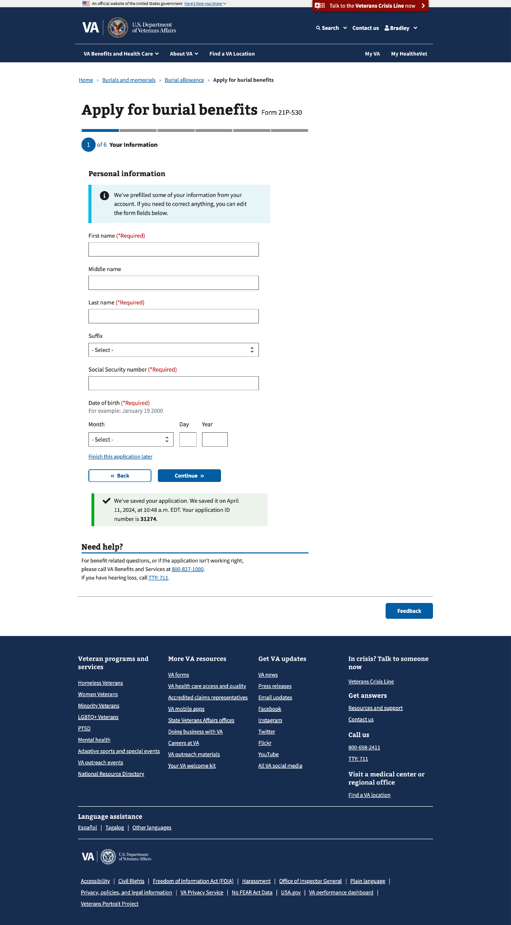

#### 1.2 Mailing address

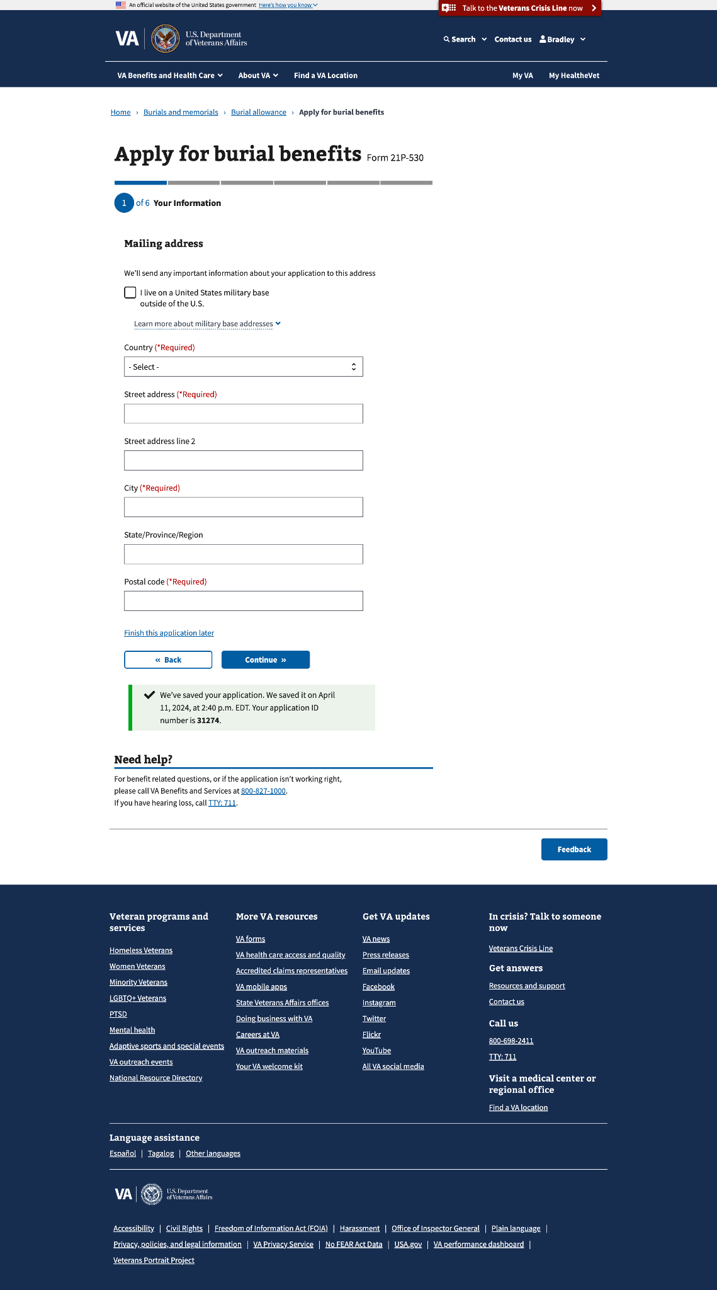

#### 1.2 Mailing address (outside the US)

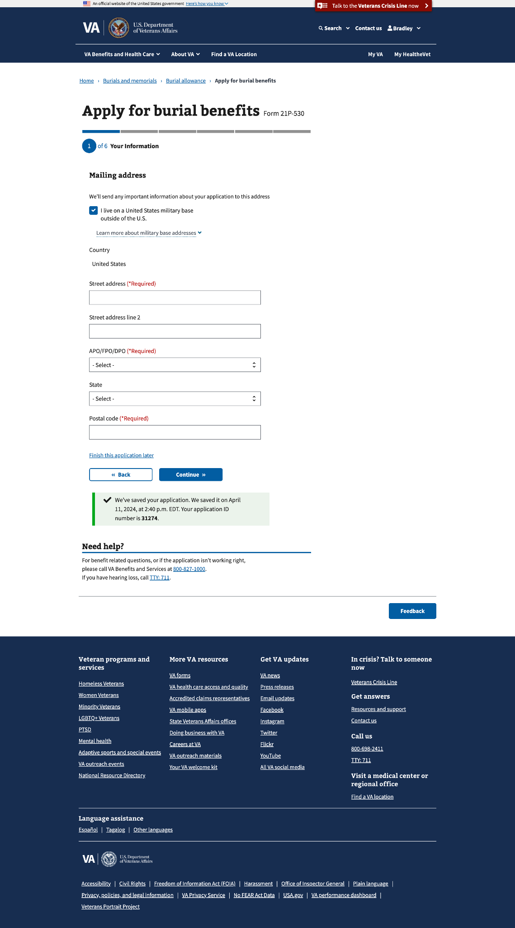

#### 

#### 1.3 Contact information

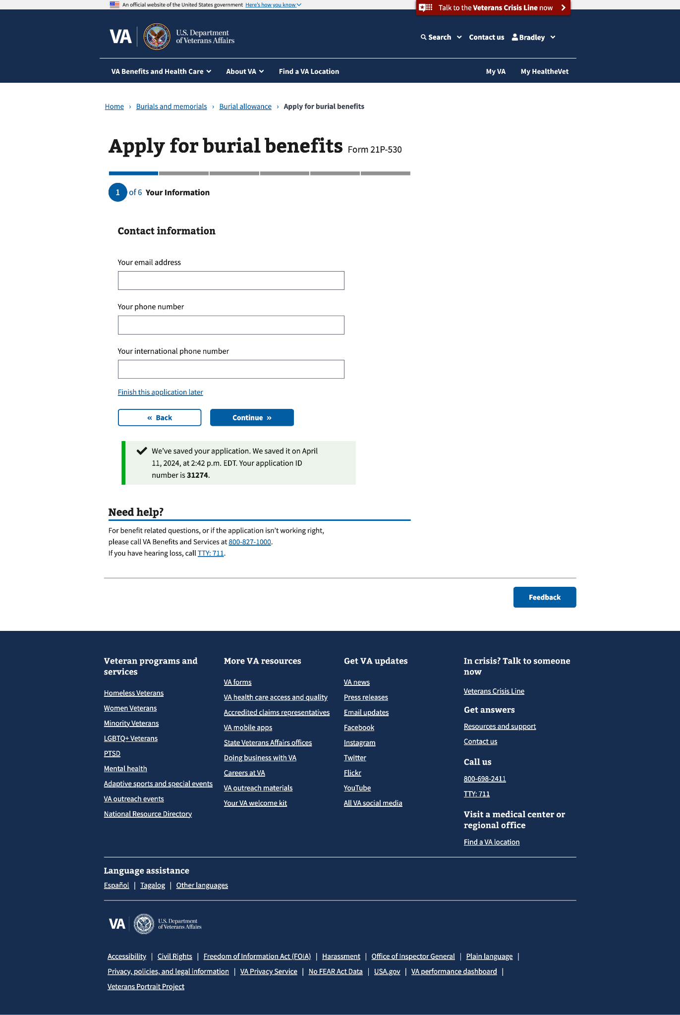

#### 

### 

### 

### 

### Step 2: Deceased Veteran information

This step has 3 sup-pages that ask about the deceased Veteran’s personal information, burial dates, and death location.

#### 2.0 Veteran’s personal information

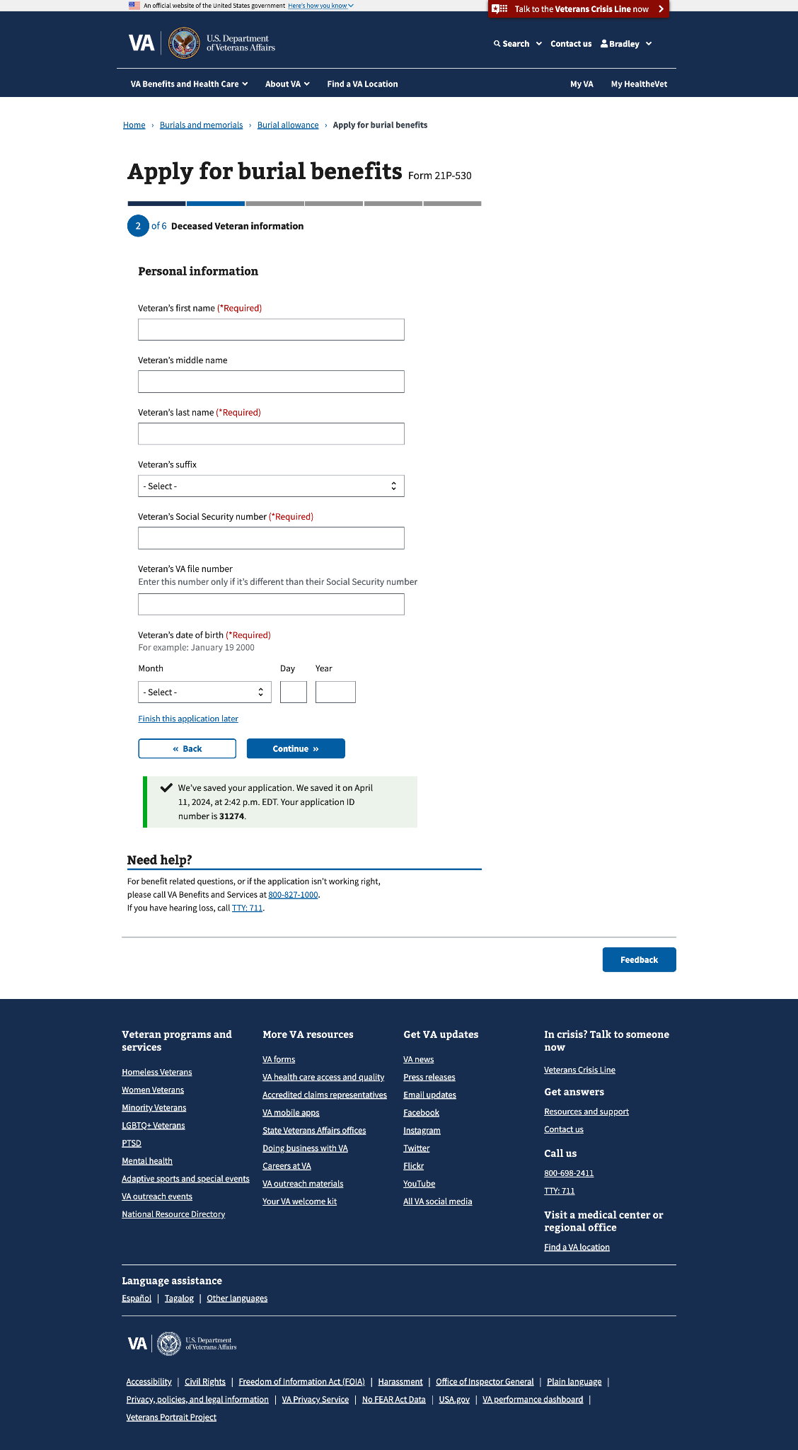

#### 2.1 Burial information

#### 

#### 

#### 

#### 

#### 

#### 

#### 

#### 

#### 2.2 Veteran death location

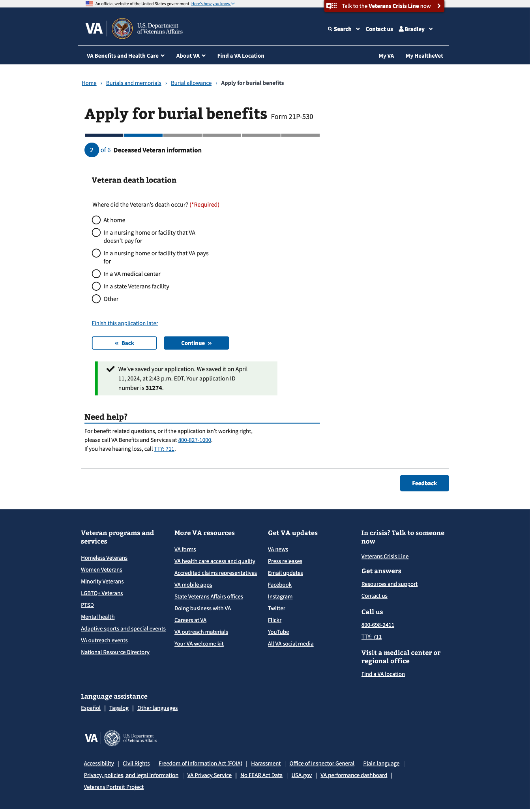

#### 

#### 2.2 Veteran death location - conditional fields

Conditional fields will appear when any of the options except at home is selected

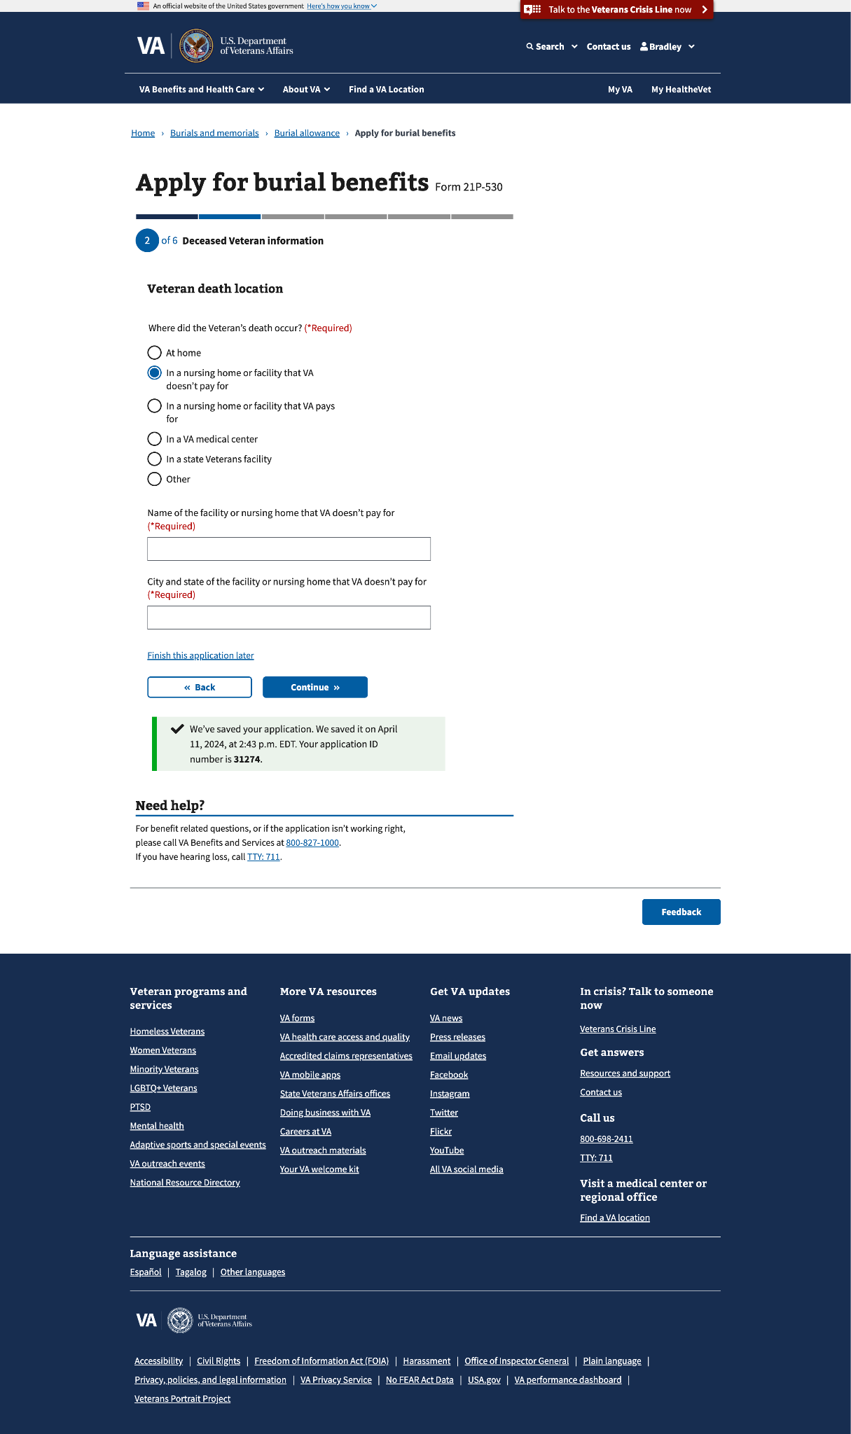

### 

### 

### 

### Step 3: Military History

This step has 4 sup-pages that ask about the deceased Veteran’s military information and any previous name the Veteran had used during their service periods. **If the claimant uploads a DD214, they will skip** a page that asks about the **Veteran’s service periods**.

#### 3.0 DD214 or other separation documents

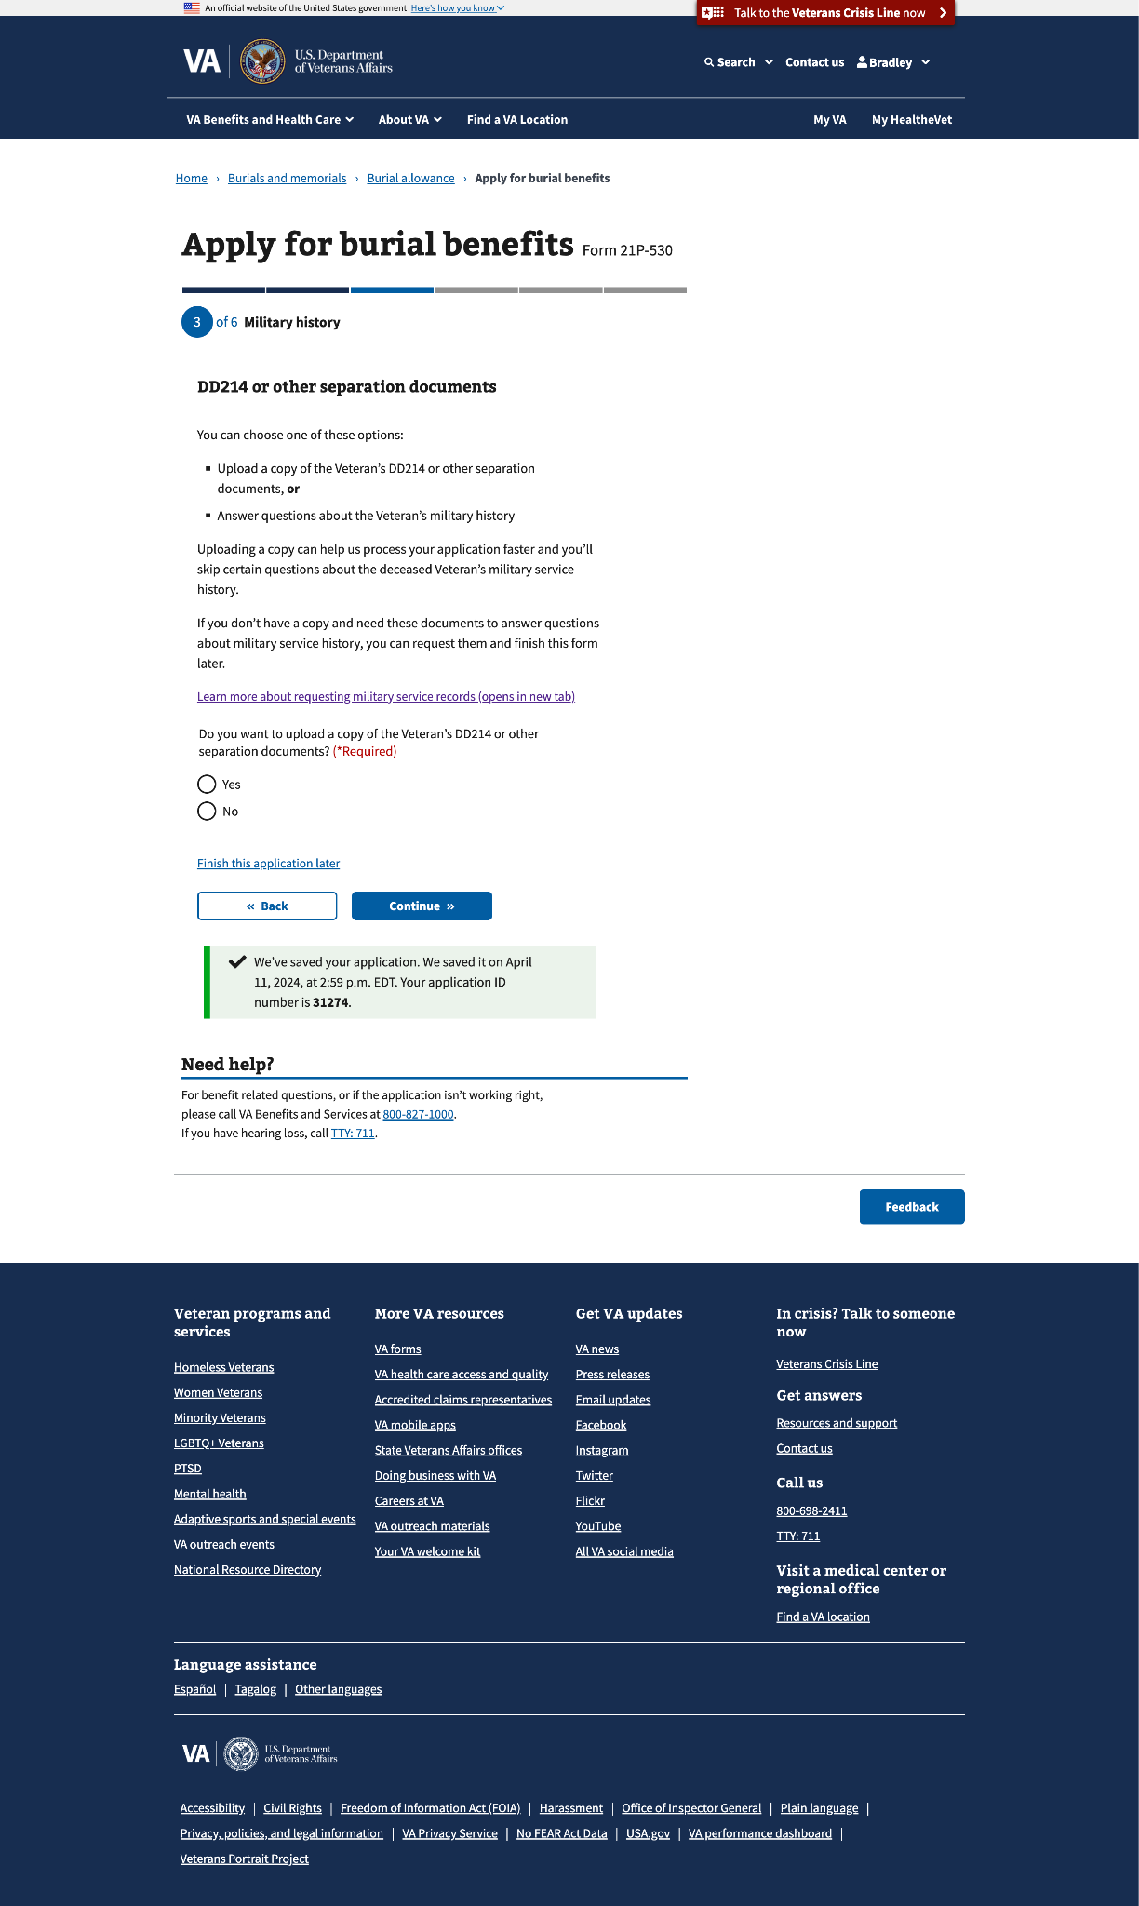

#### 

#### 3.1 DD214 or other separation documents (upload screen)

This page will appear if they select “Yes” to the “Do you want to upload a copy of the Veteran’s DD214 or other separation documents?” question on the previous screen.

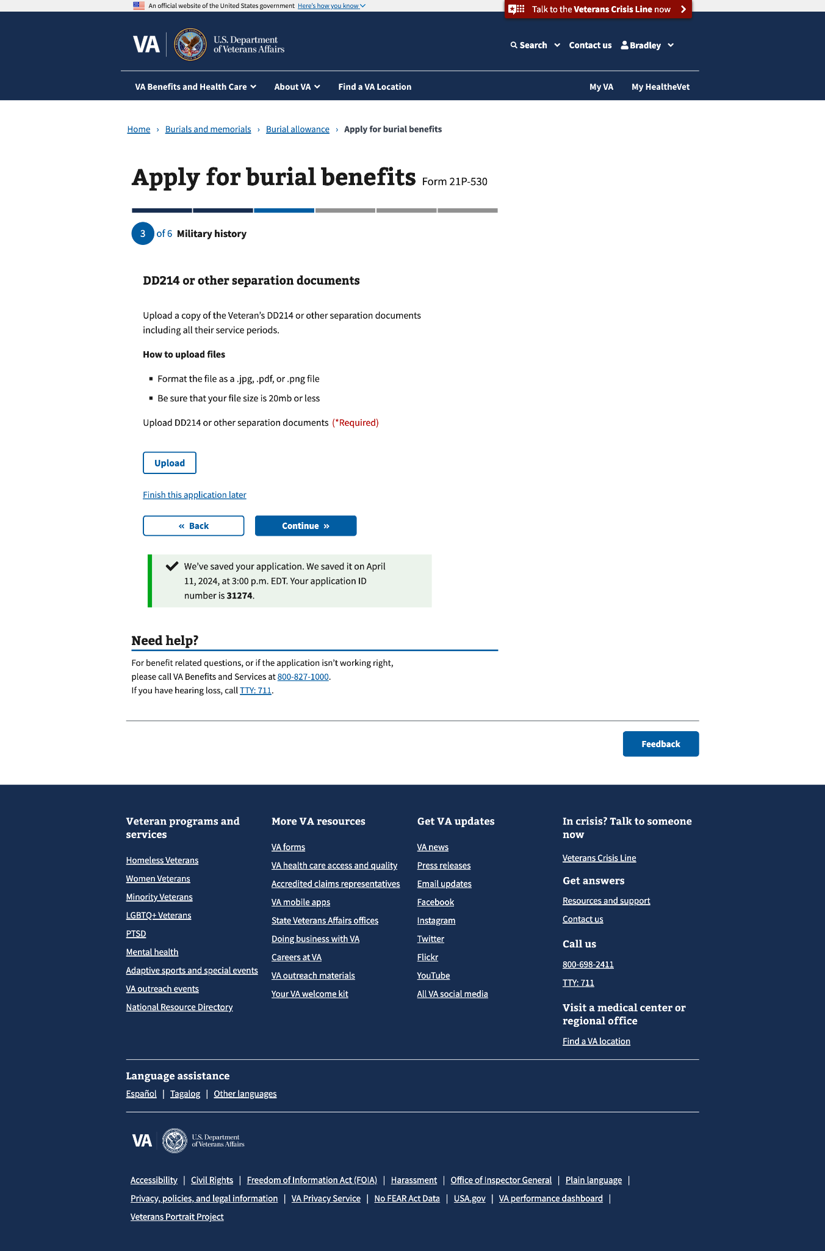

You can upload multiple documents

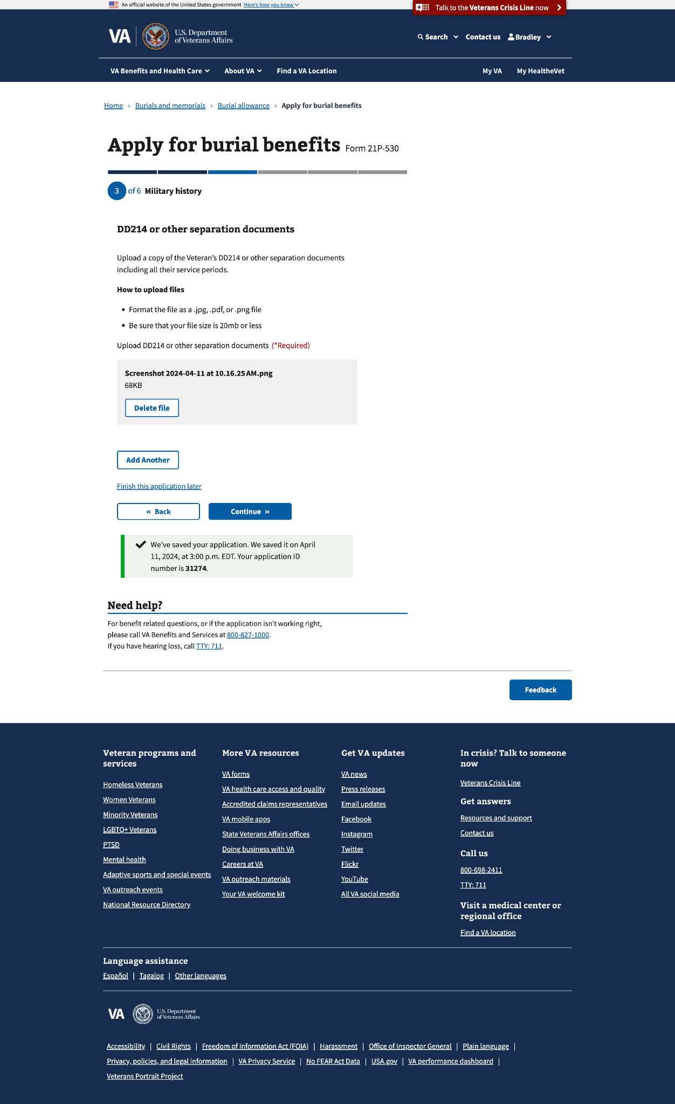

#### 3.2 Service periods

This page will appear if they select “No” to the “Do you want to upload a copy of the Veteran’s DD214 or other separation documents?” question on the previous screen.

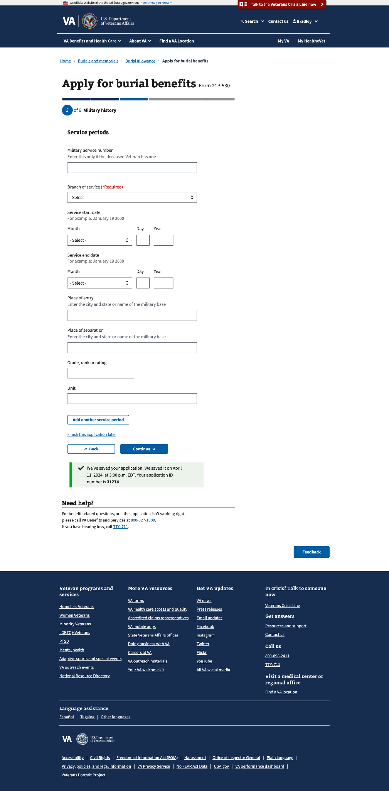

You can add multiple service periods

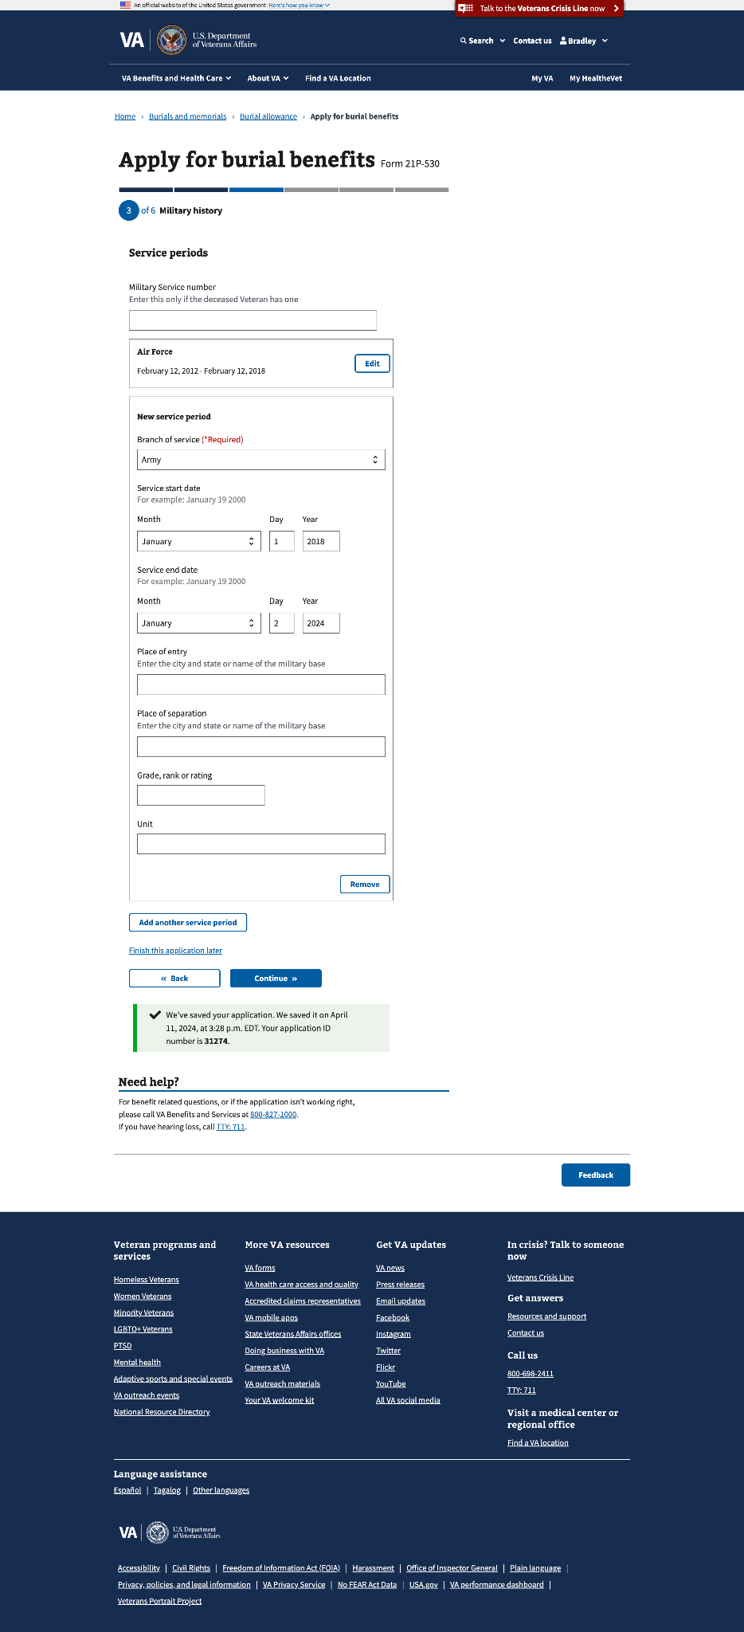

#### 3.3 Veteran’s previous names

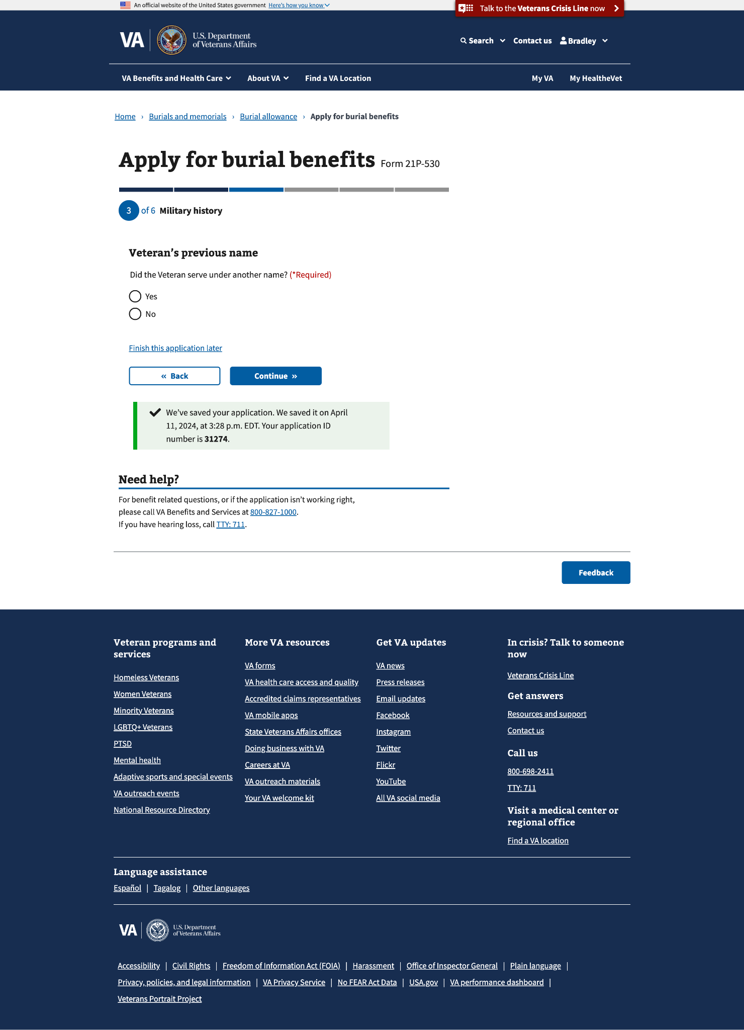

#### 

#### 3.4 Add Veteran’s previous name

This page will appear if they select “Yes” to the “Did the Veteran serve under another name?” question on the previous screen.

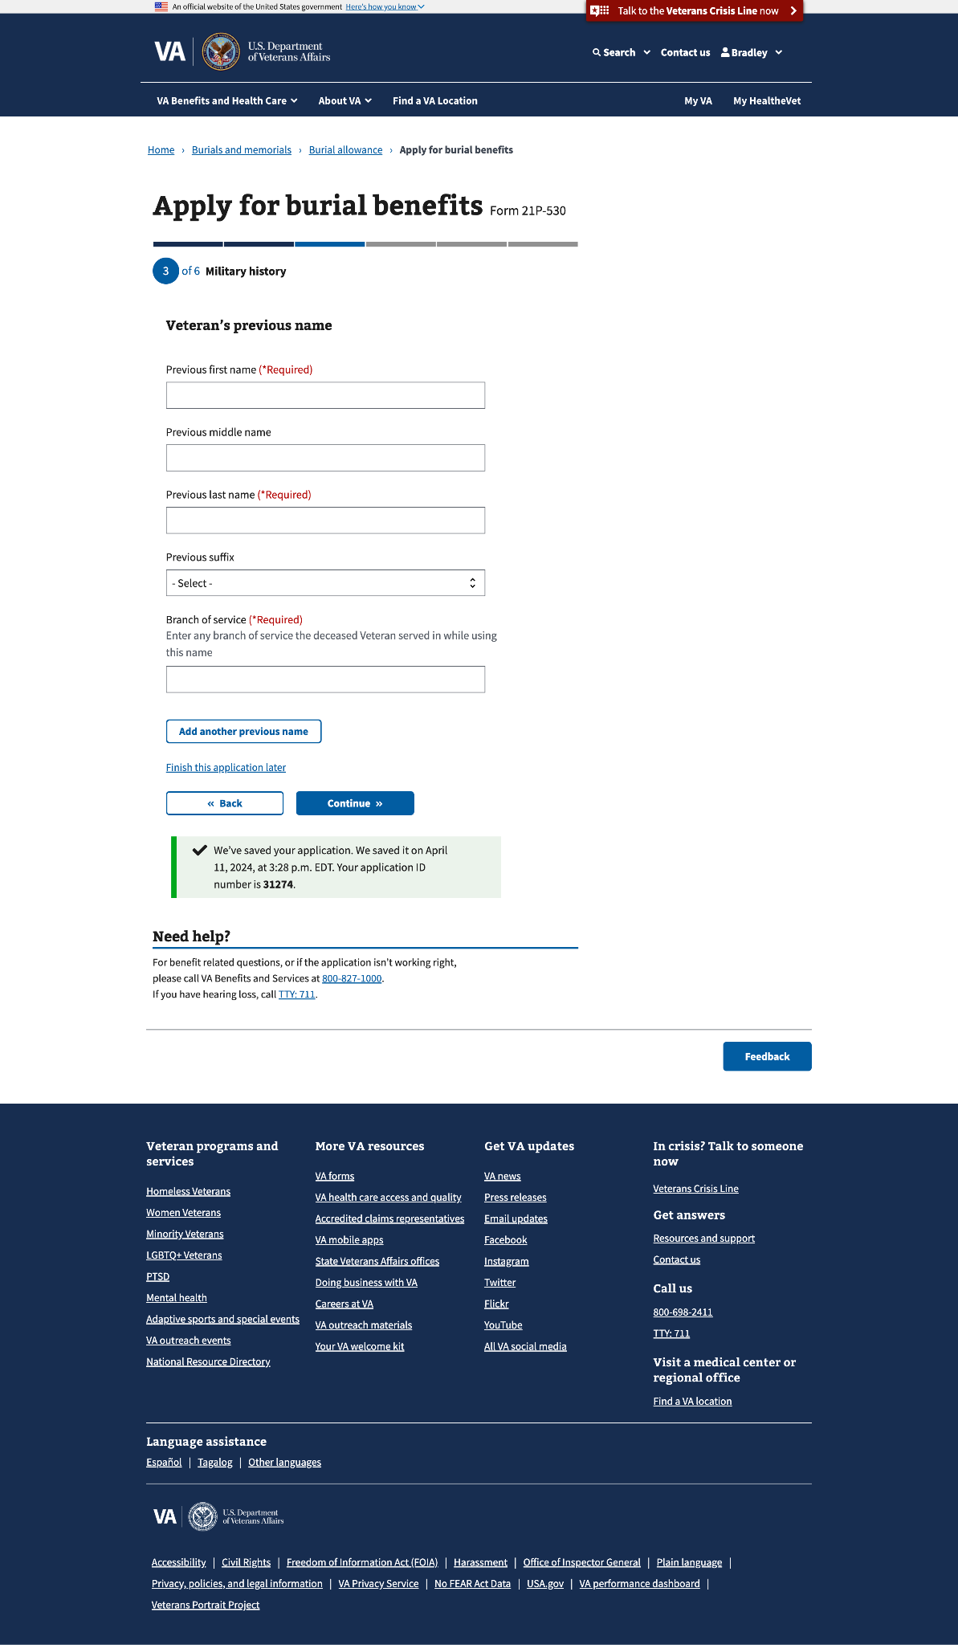

You can add multiple previous names

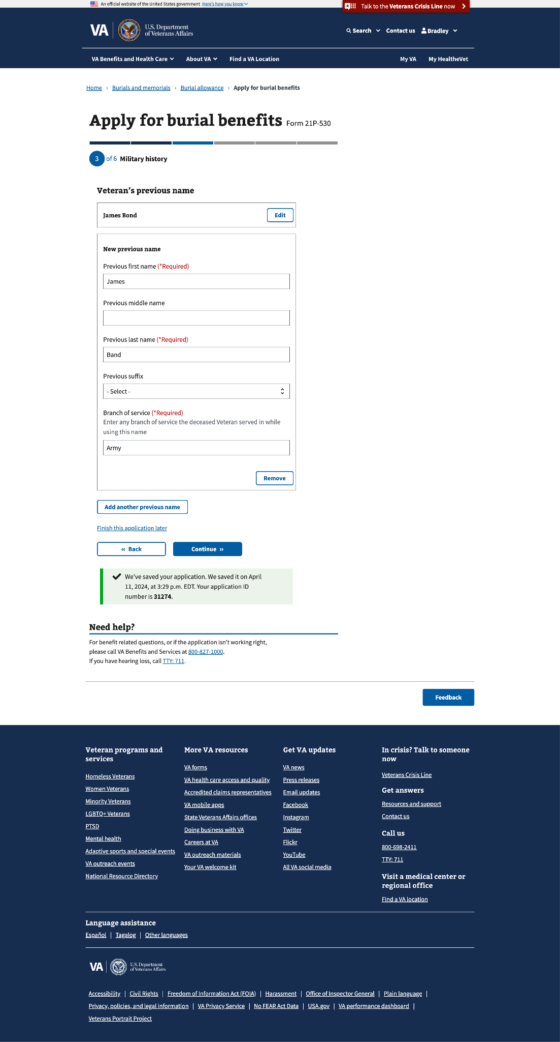

#### 

### Step 4: Benefit selection

This step can have up to 9 sub-pages, depending on the allowances they are applying for:

* Burial and funeral costs
* Costs for the plot (gravesite) or interment
* Transportation costs of transporting the Veteran’s remains to the final resting place

#### 

#### 4.0 Costs you paid for

Based on the selection(s) on this page, there will be several pages that the claimant will have to go through.

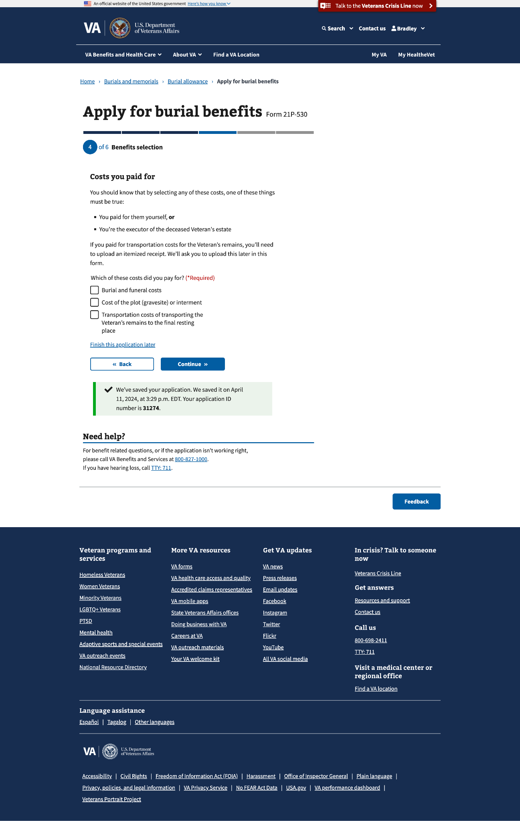

#### 

#### Burial and funeral costs

This benefits selection could render up to 3 subpages.

##### 4.1 Burial allowance

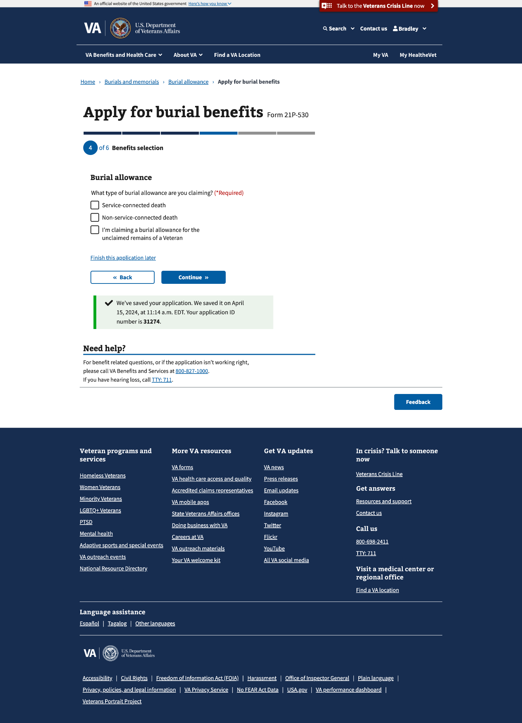

##### 4.2 Type of burial allowance

If “I’m claiming a burial allowance for the unclaimed remains of a Veteran” (last option) is selected, a new page will appear with a statement that needs to be confirmed by the claimant.

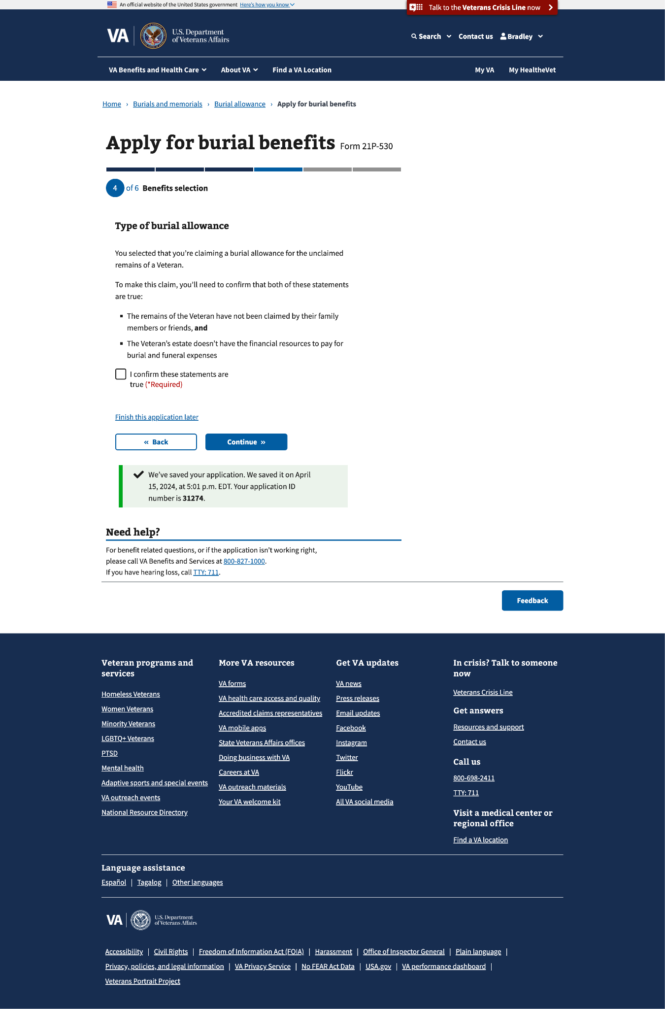

##### 4.3 Burial allowance (Con’t)

#### 

#### Cost of the plot (gravesite) or interment

This benefits selection could render up to 6 subpages.

##### 4.4 Final resting place

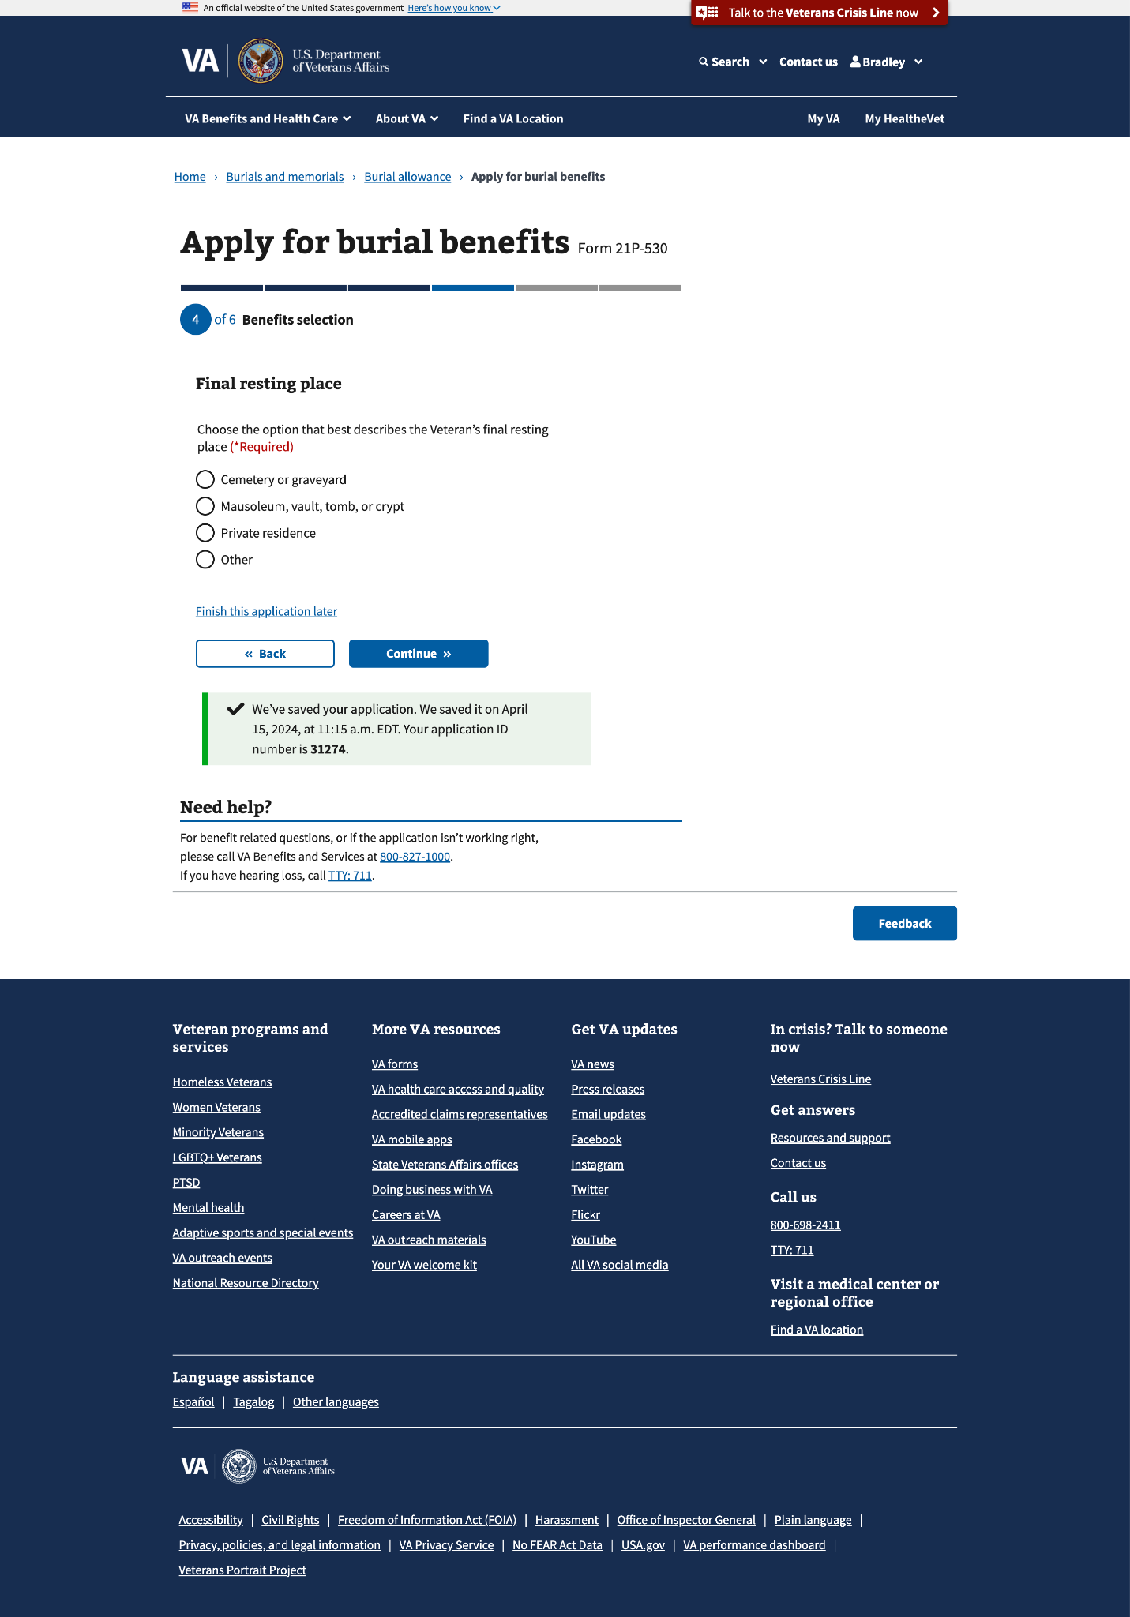

If “Other” is selected, a conditional field will appear to specify the final resting place of the deceased Veteran’s remains

#### 

#### 

##### 4.5 Cemetery location

##### 

If “Yes” is selected, a conditional field will appear to specify the name of cemetery

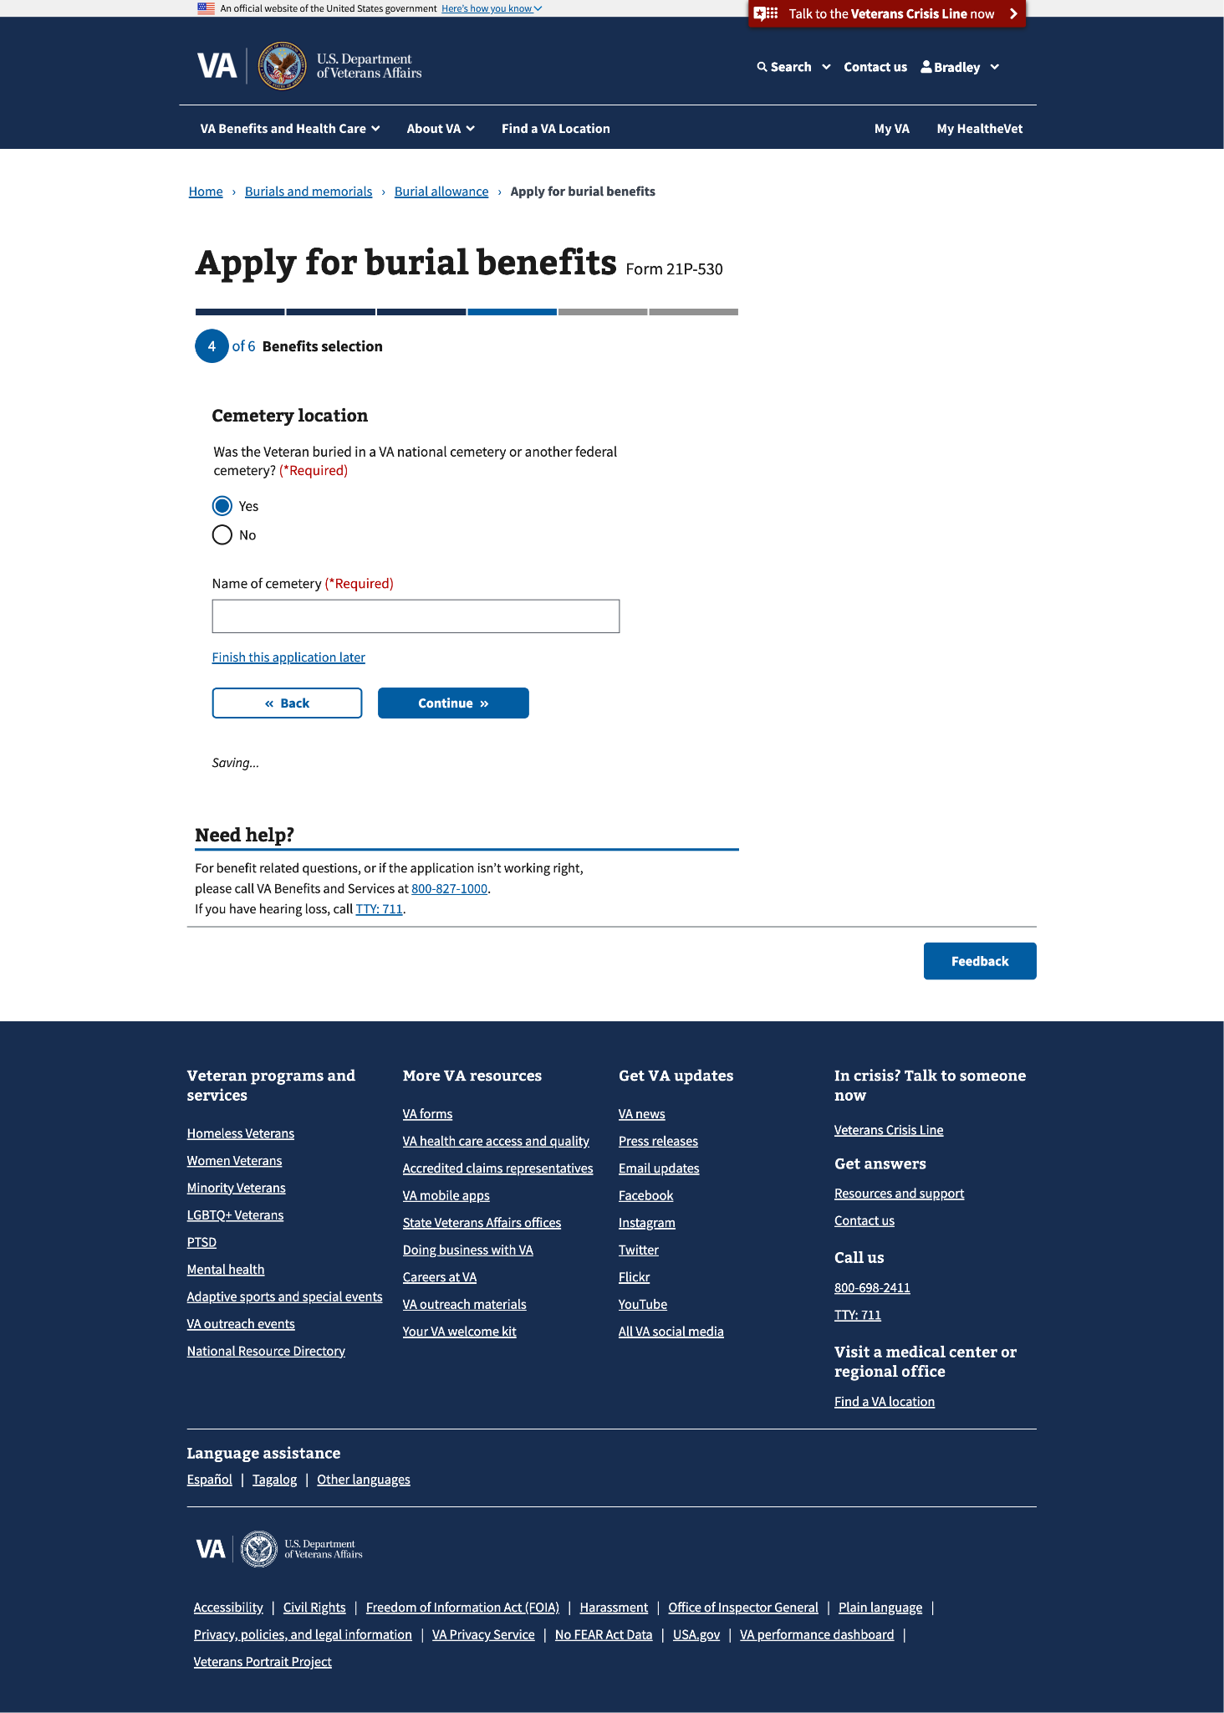

##### 4.6 Cemetery location (con’t)

#### 

##### 4.7 Cemetery location (con’t)

If either “Yes, in a state cemetery” or “Yes, on a tribal trust land” is selected a new page will appear, where the claimant needs to specify the name and zip code of either the state cemetery or tribal trust land.

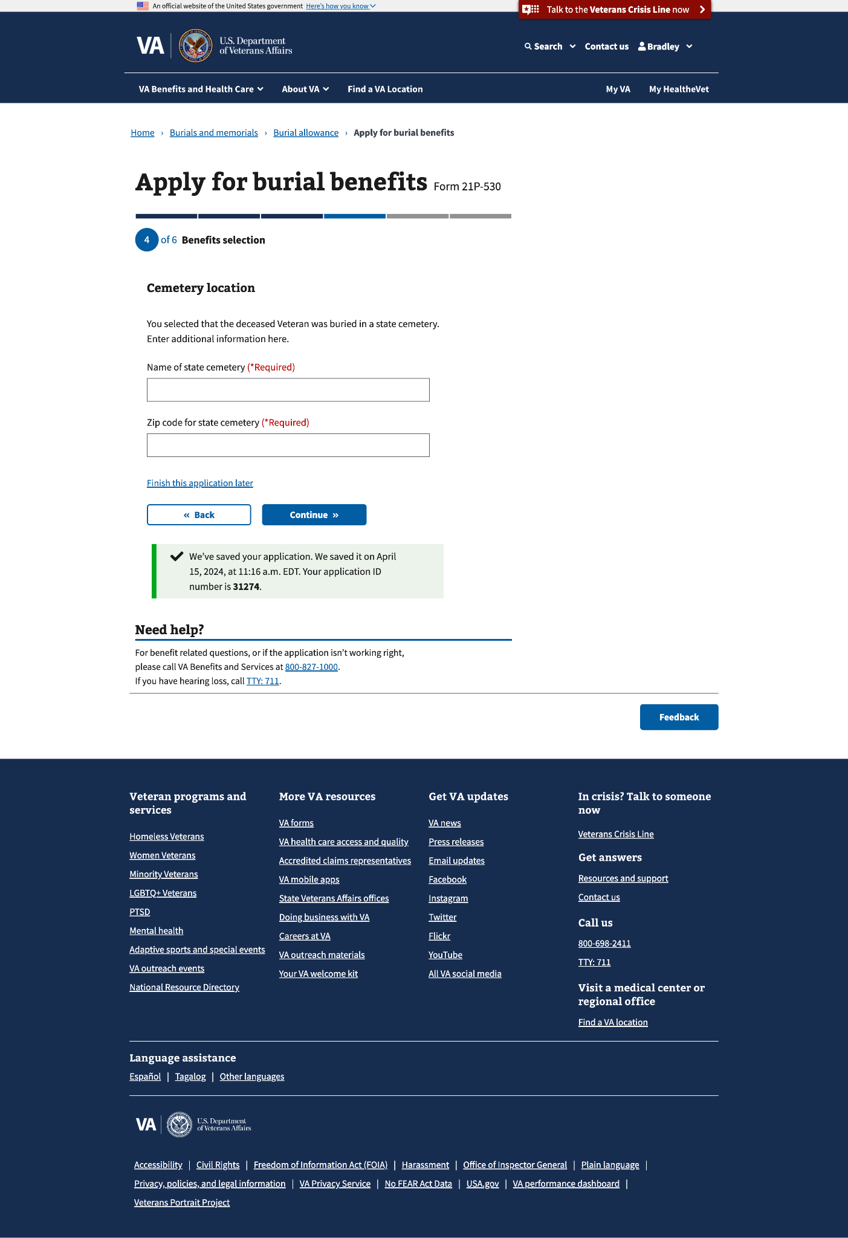

##### 4.8 Plot or interment allowance

##### 

If “Yes” is selected, the claimant will need to provide the amount the government or employer paid

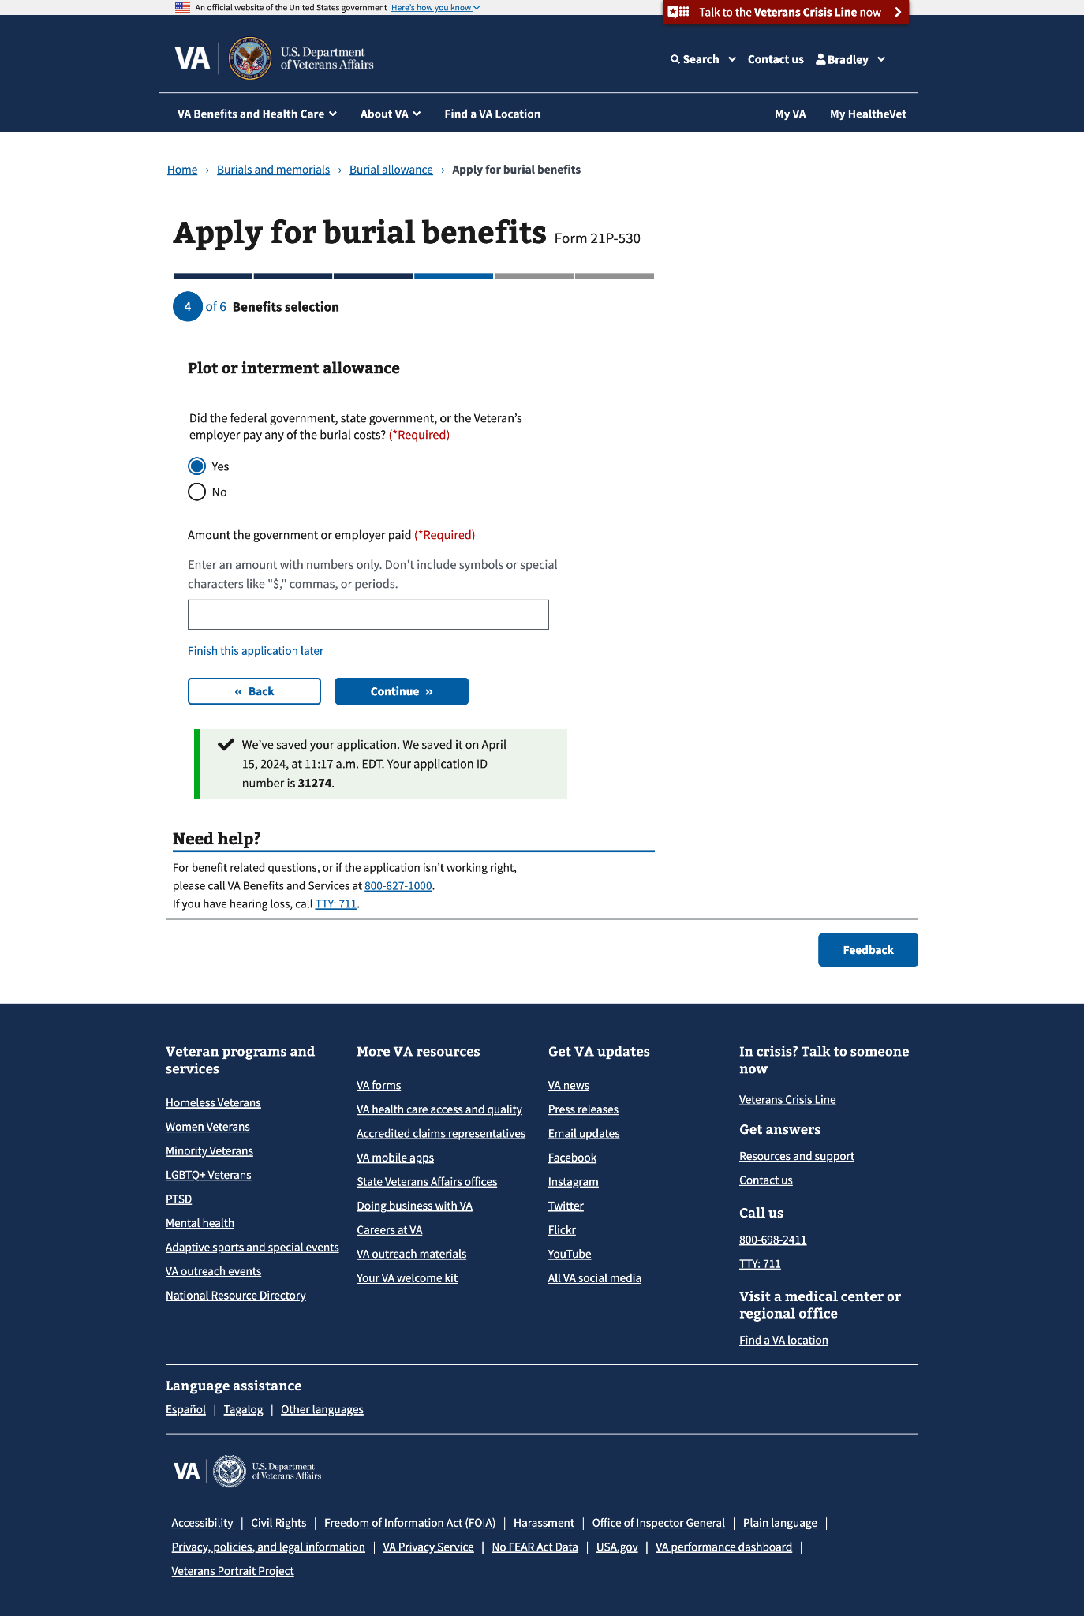

##### 4.9 Plot or interment allowance (con’t)

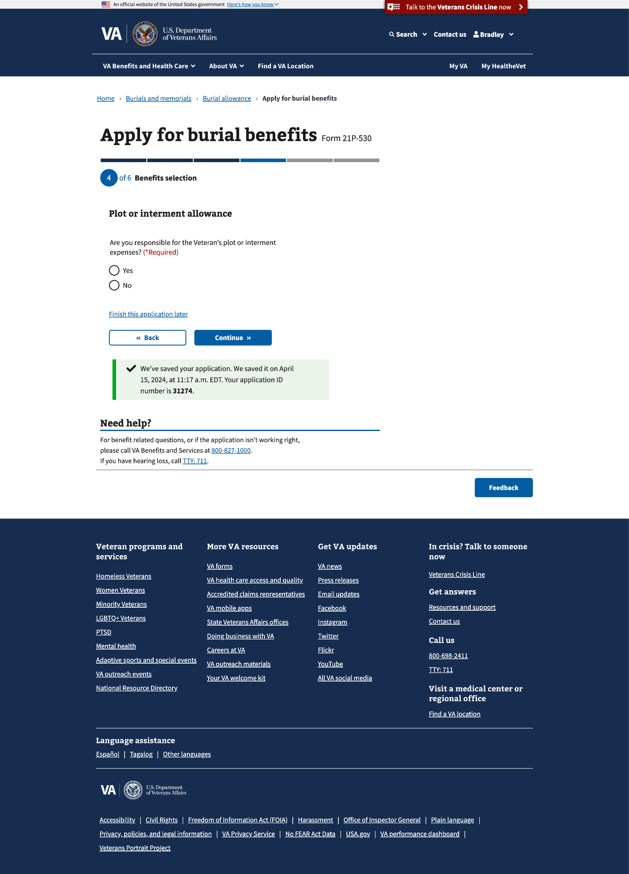

#### 4.10 Transportation costs

### 

### Step 5: Upload documents

This step can have up to 3 sub-pages that ask the claimant to upload the Veteran’s death certificate, transportation costs (**if they selected to apply for this allowance**), and any additional documents.

#### 5.0 Death certificate

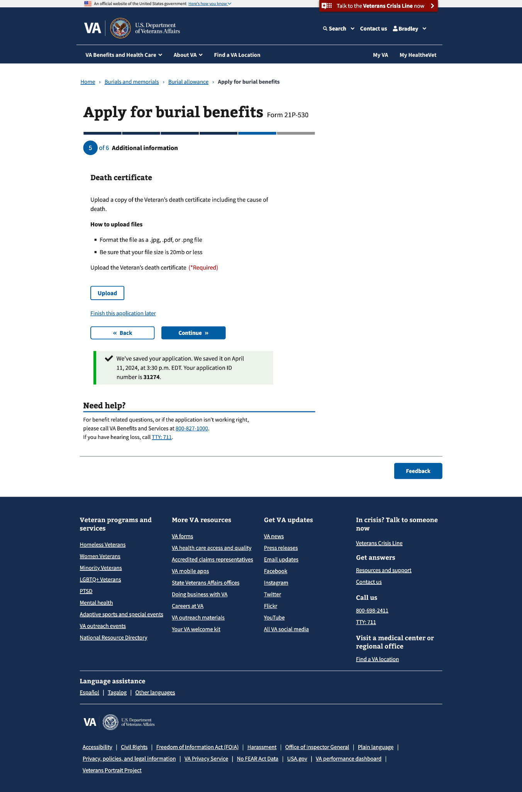

You can upload more than one

#### 

#### 5.1 Transportation costs

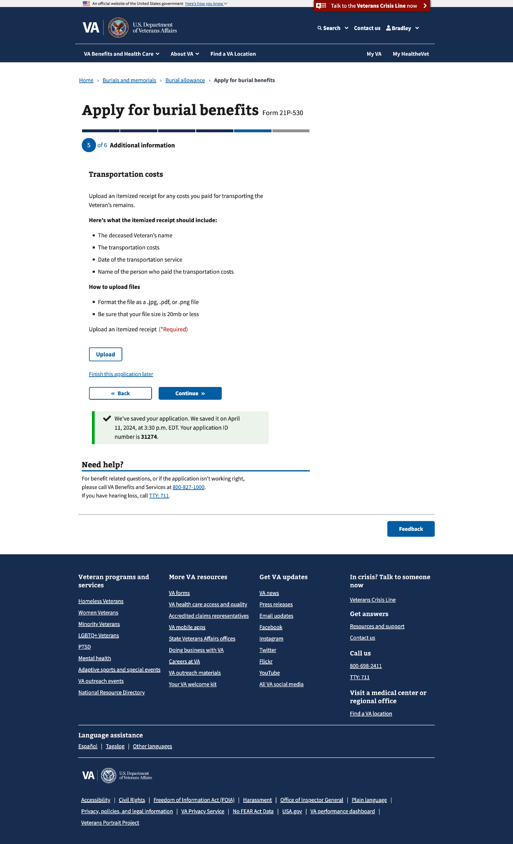

You can upload more than one

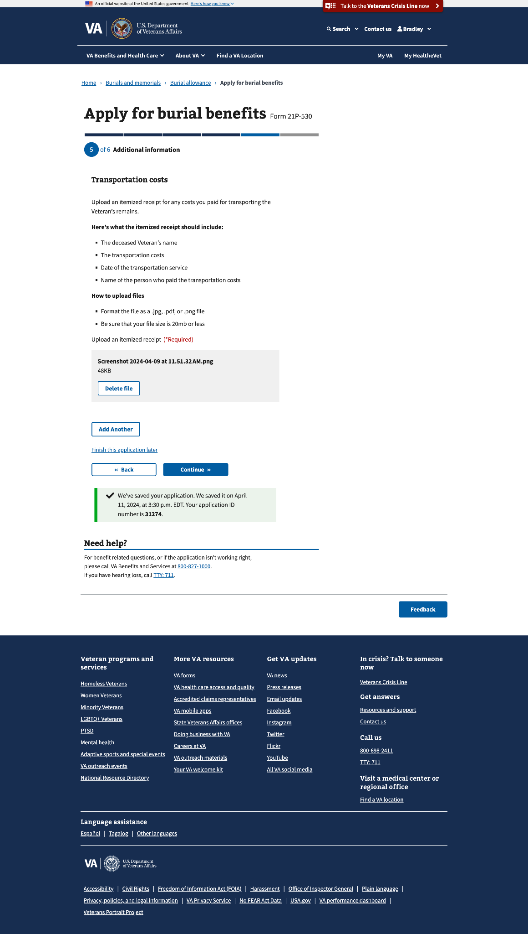

#### 

#### 5.3 Additional evidence

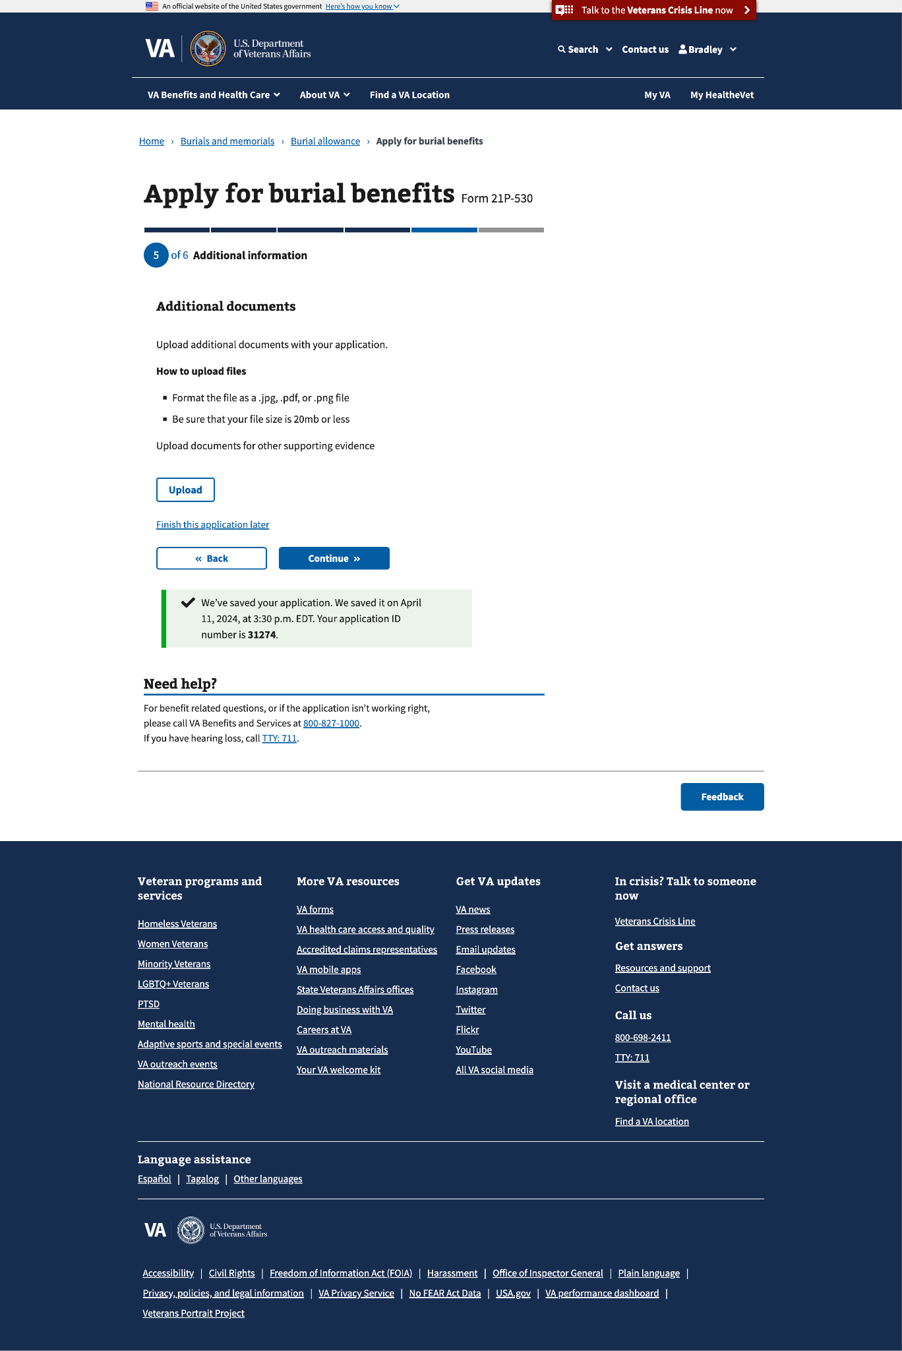

You can upload multiple documents

#### Faster claim processing

#### 

### Step 6: Review

In this step, the claimant can review all the information entered, edit sections, and submit the application.

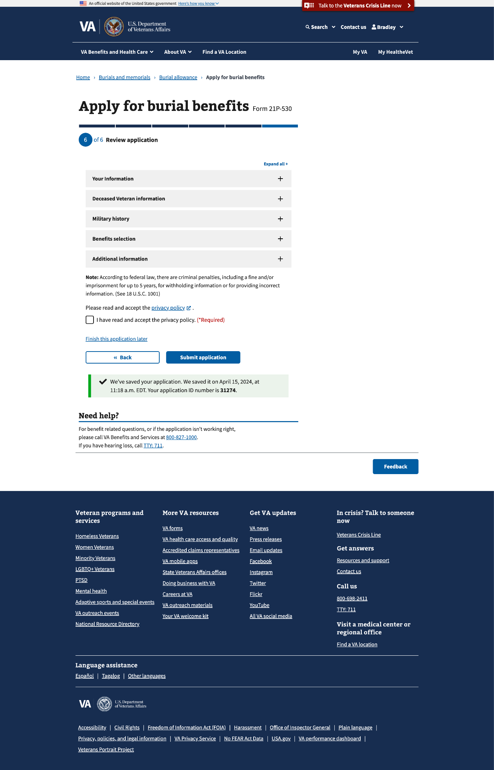

### 

### Confirmation

After the claimant submits this form, they will view a confirmation page that lists the following:

* Who submitted the form, confirmation number, date submitted, deceased Veteran, benefits claimed, documents uploaded, and the Pension Management Center as the place it was sent to

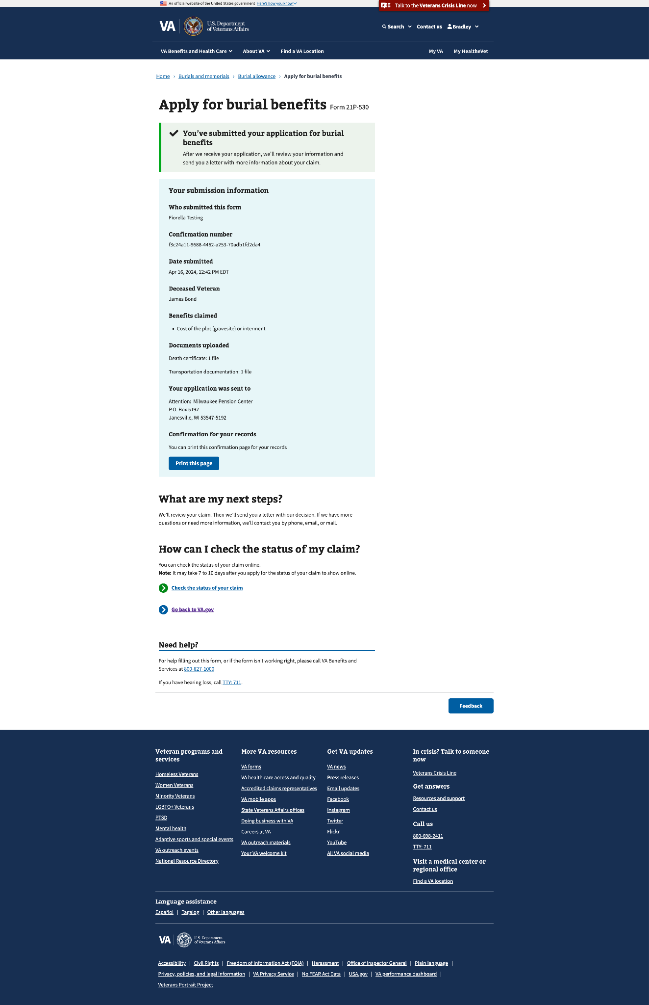

### Email confirmation

The claimant will also receive the information on the confirmation page as an email.

## 5. Major Issues and Error Messages

#### Required response

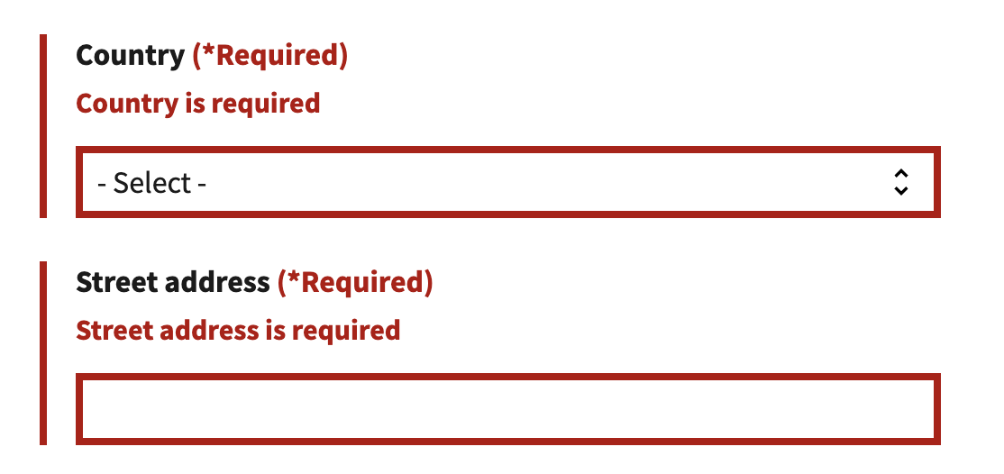

#### Privacy policy

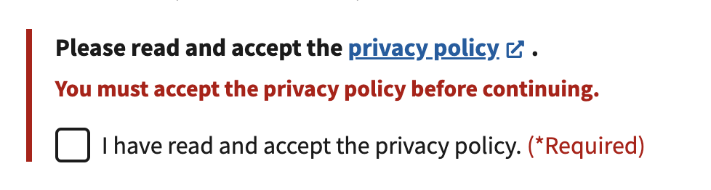

#### Missing information

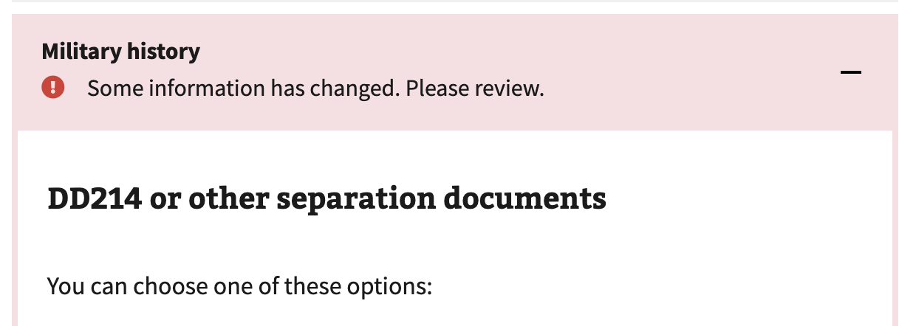

#### Submission failure

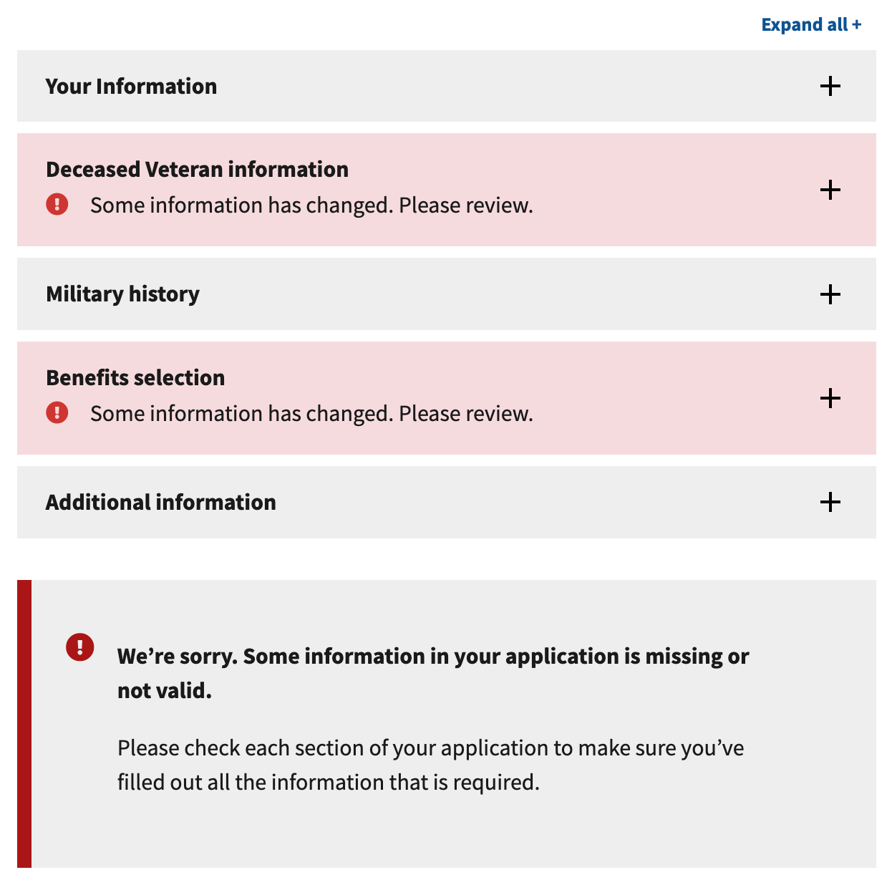

#### Connection error

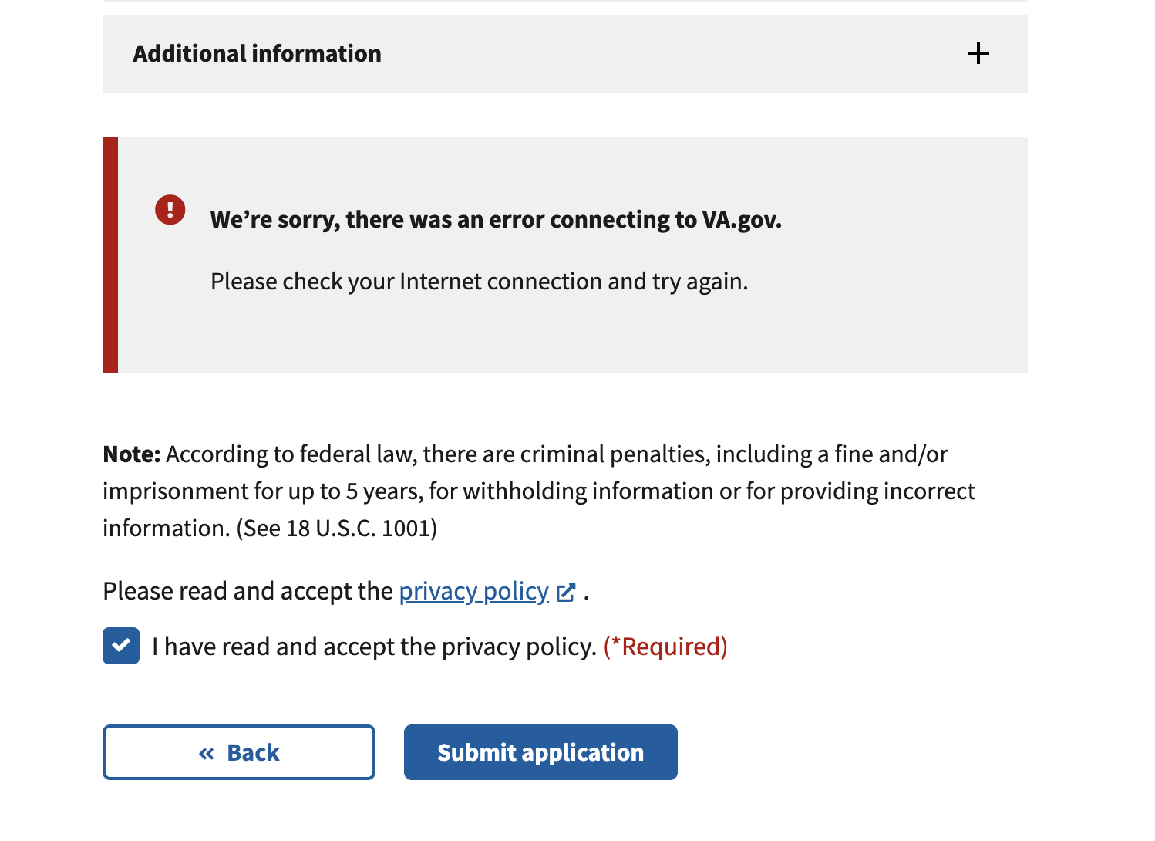

EXAMPLE: IN-TEXT REFERENCE TO IMAGES

**TRY TO KEEP TEXT AND IMAGE ON SAME PAGE; INSERT PAGE BREAKS AS NEEDED.** Body text. Body text (See Figure 2).

  
*Figure 2. A brief caption, 9-point italic.*

**Table of Figures**

Figure 1: Caption 1

Figure 2: Caption 2